User Manual

 **Asset Tagging and Tracking System**

SATS: Web Portal

**User Manual Version 1.0**

April, 2024

The software described in this document is furnished under a non-disclosure agreement or a license agreement. The software may be used for copying, only in accordance with the terms and conditions as per the agreement. Information in this document is subject to change without any notice.

**Table of Contents**

1. Document Revision History 4

2. Acronyms & Glossary 5

3. Introduction 6

4. Login, Home Page, Menu 7

4.1 Login 7

4.2 Home Screen 8

4.3 Hamburger Menu 8

5. Pending Approval 9

6. Technician to Site Tagging Status 11

7. Operator Site View 12

8. Technician Supervisor Mapping 14

9. Site Asset View 15

10. Asset History 19

11. Configuration Management 20

11.1 Asset Type 20

11.2 Asset Attribute 22

11.3 Site Type 24

11.4 Site Attribute 24

11.5 Site 26

12. Batch Process 27

12.1 Technician to Site Mapping 27

12.2 Add Asset 28

12.3 Create STN 29

12.4 Create SRN 30

12.5 ERP FAR Update 30

12.6 Reports 31

13. Audit Trail 32

14. Report 33

15. Log Out 34

# Document Revision History

|  |  |  |  |
| --- | --- | --- | --- |
| **Sl. No.** | **Version No.** | **Description** | **Date of Release** |
| 1 | 1.0 | Web Portal for Asset Tagging and Tracking System | April, 2024 |
|  |  |  |  |
|  |  |  |  |

# Acronyms & Glossary

|  |  |
| --- | --- |
| **Abbreviation** | **Description** |
| SATS | SSTL Asset Tagging and Tracking System |
|  |  |

# Introduction

This document provides operation steps for the SATS Web Portal users. This document provides operational information on how the user can do various operations in SATS Web Portal. This document is created based on the Web Portal developed and delivered to SSTL for asset tagging and tracking system.

Web portal application is for system administrators and supervisors to configure the system as well as view different information. It allows supervisor to view and manage technicians under them, configure master data. It also allows to view site and asset related information.

# Login, Home Page, Menu

## Login

1. Login to user management by entering user id and password.

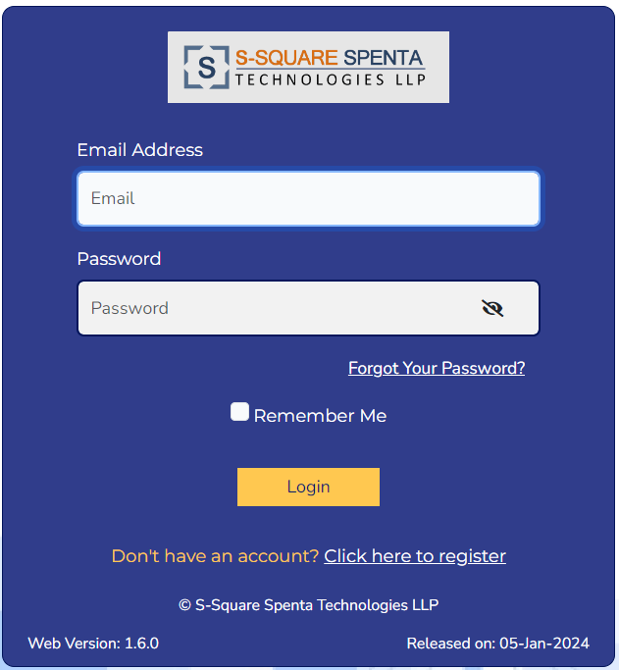

1. User will be landed at the dashboard of user management screen.

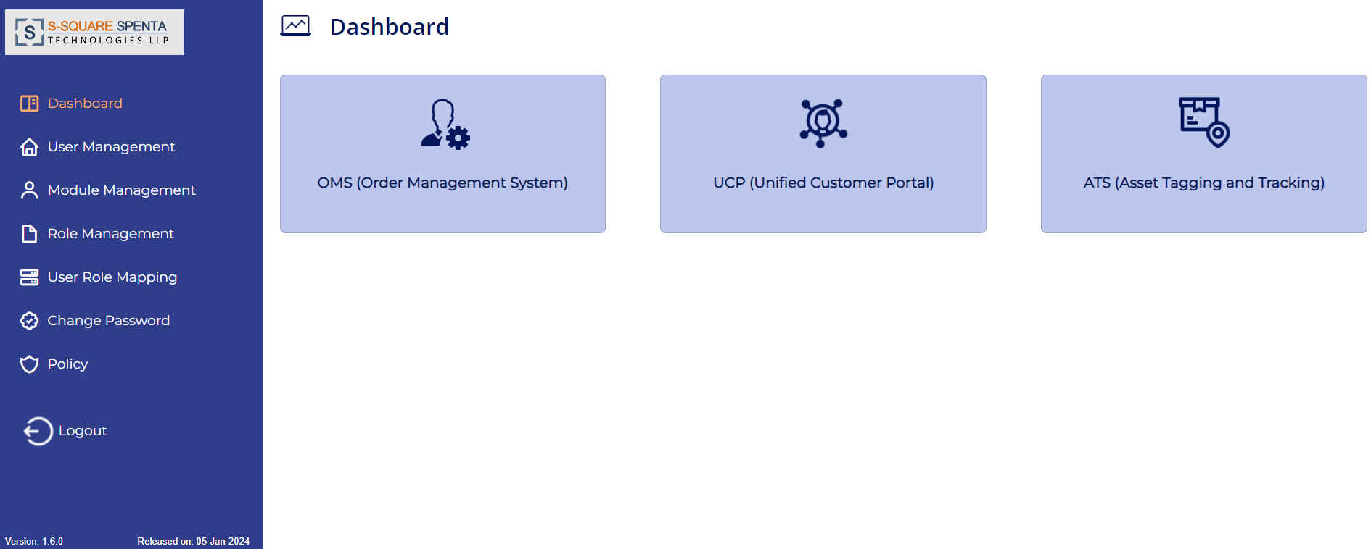

1. Click on the ATS module from the dashboard screen. User will be login into the Web Portal Home Page.



## Home Screen

The following screen will be displayed after successful login into the Web Portal.



## Hamburger Menu

1. Click on the Hamburger menu button on the top left corner of the home screen.
2. The side menu bar will expand and display the following menu item:

* Home
* Pending Approval
* Technician to Site Tagging Status
* Operator Site View
* Technician Supervisor Mapping
* Site Asset View
* Asset History
* Configuration Management
* Batch Process
* Audit Trail
* Report
* Log Out

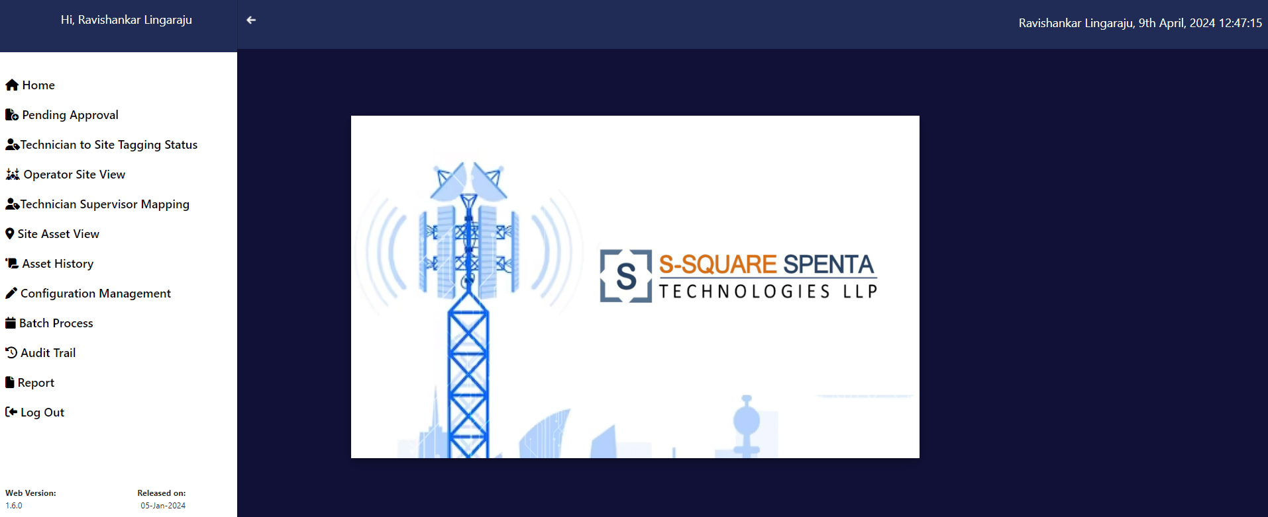

# Pending Approval

Pending Approval refers to the list of tasks (e.g. Add Assets, Edit Asset, STN, SRN, Tagging) that have been performed by the technician and are now awaiting approval or rejection by supervisor.

1. Click on the Pending Approval option from the menu option. User will get the task list pending for approval by supervisor.

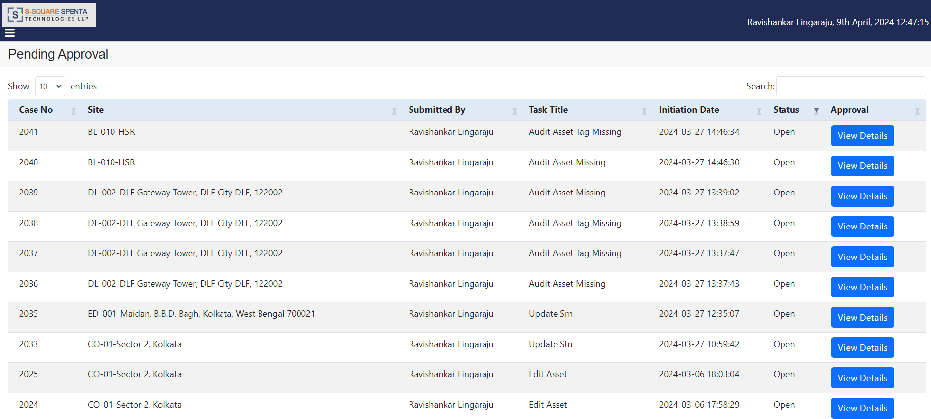

1. A search option is available for users to find access specific tasks.
2. Click on the 'View Details' button of a task, it will redirect you to the Process Maker pop-up screen, where users can review and take action to either approve or reject the task by clicking the “Accept” or “Reject” button. Turn-off the pop-up blocker of your browser before clicking on the view details.

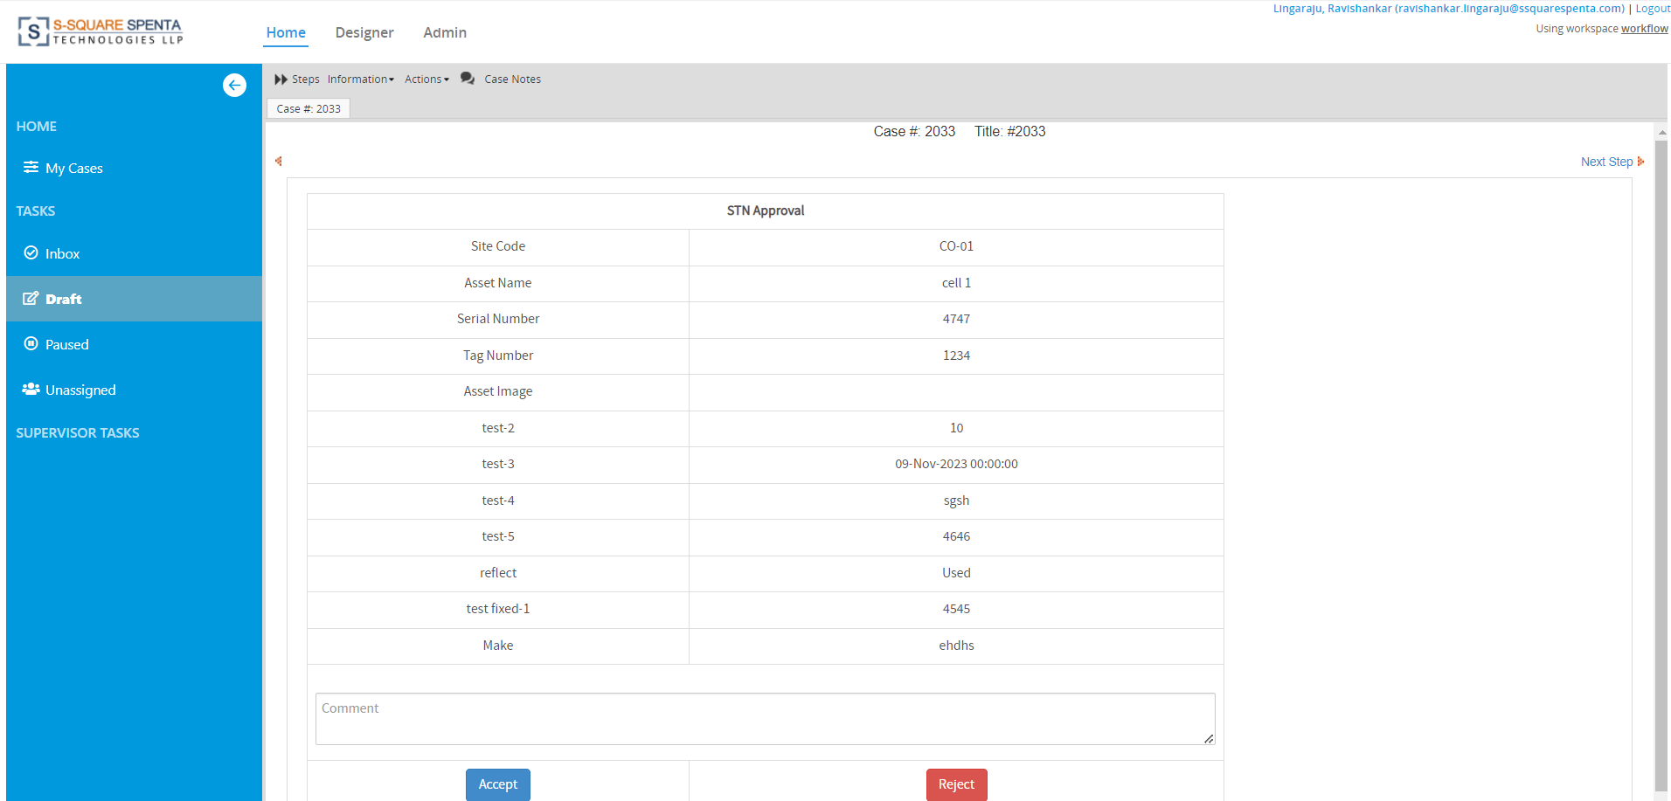

1. Click on the Accept option to approve the task. Then user will get option to finish and close the task.
2. The data change will be reflected in the Web portal and Mobile App closing the task.
3. Supervisor can disapprove the task by clicking on the Reject option. User may put some remarks to mention the rejection reason of the task.

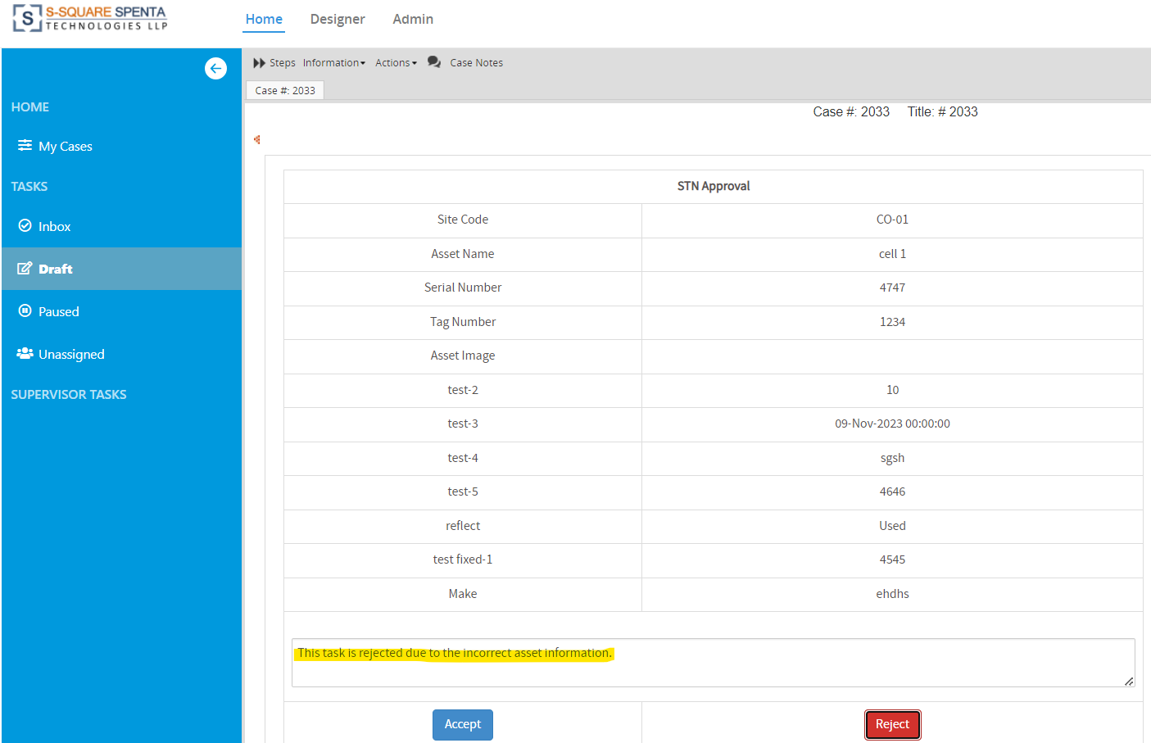

1. After approval or rejection using the Accept or Reject button the pop-up tab will be redirected to the End of Process screen, where the user will confirm the approval or rejection performed by clicking Finish button.

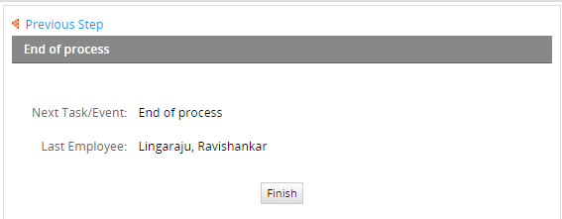

# Technician to Site Tagging Status

1. On clicking the Technician to Site Tagging Status from the hamburger menu the following page is displayed.

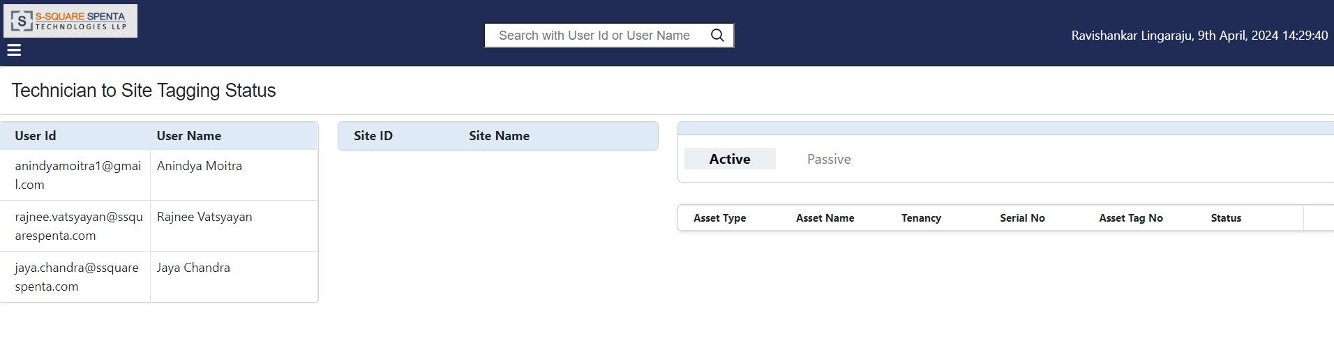

1. The technicians assigned to the logged in Supervisor are listed in the User Id list.
2. On clicking the User id, The Sites assigned to the selected Technician are listed in the Site Id list along with the Site Status color.

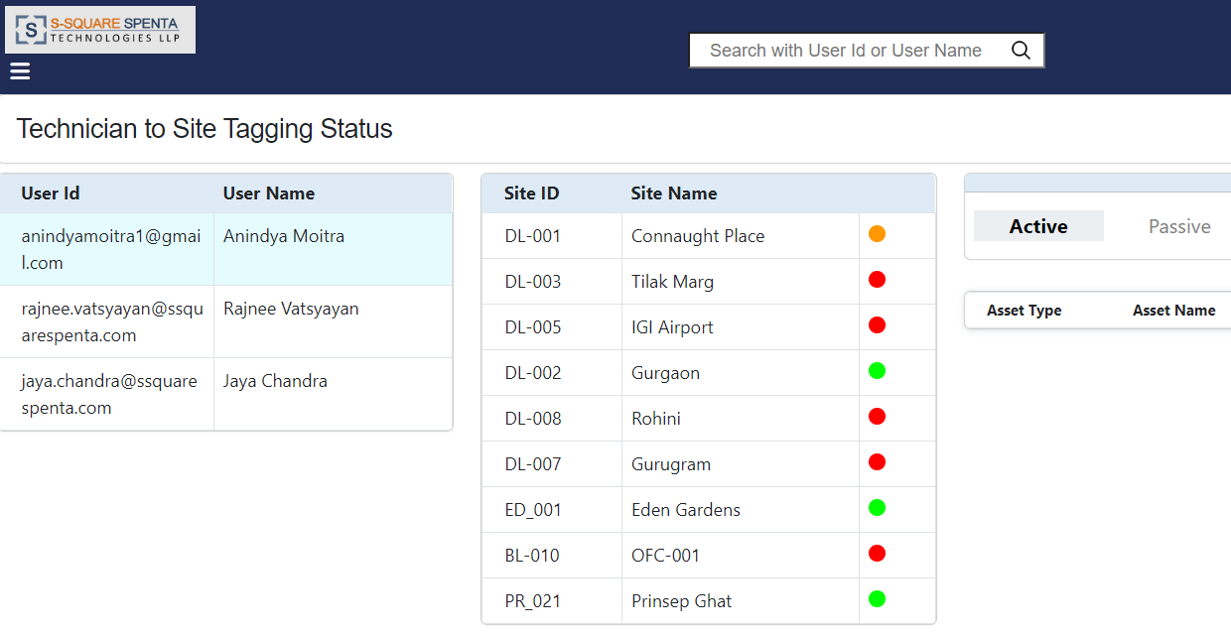

1. Clicking on a site, the active and passive assets assigned to the selected Site ID are listed in the Asset Details list.

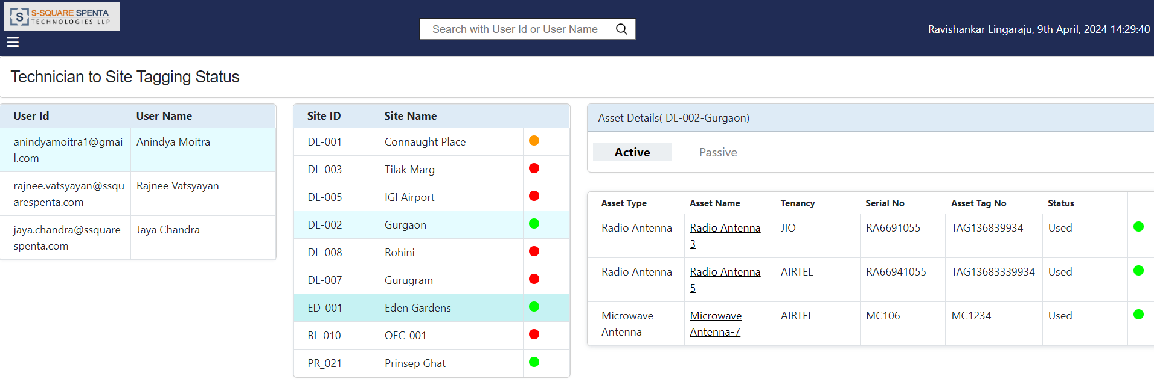

1. The Asset Tag Status color coding is displayed, along with Tenancy (only for Active assets), Serial no., Asset tag no., Status.

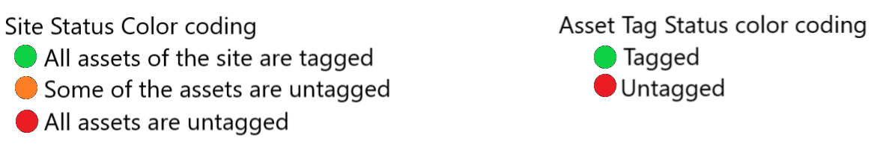

1. User can toggle between Active and Passive assets tab.
2. Clicking on any of the Asset Name will open a pop-up tab with the details of that particular asset. Asset detail displays the tagging history also.

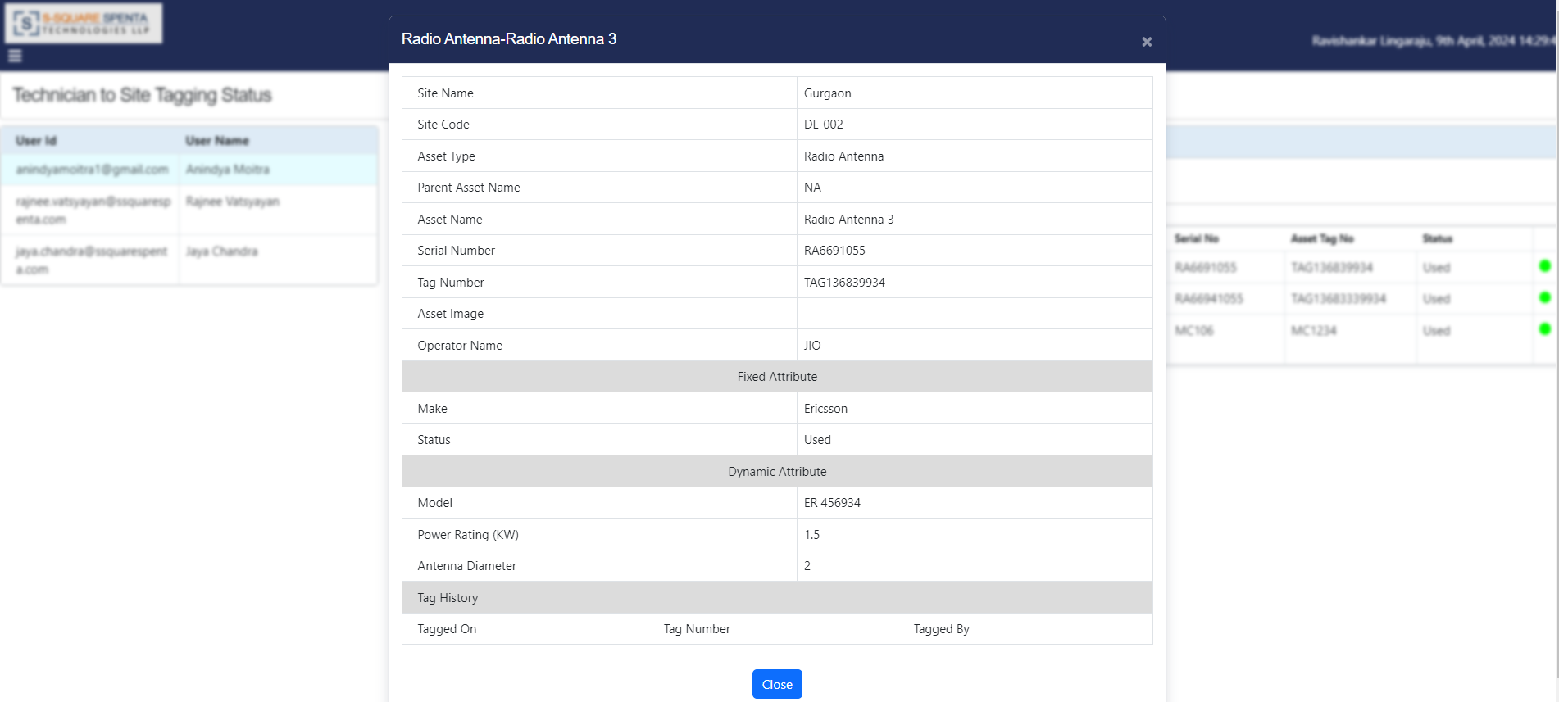

1. Click on the Close button to close the asset details pop-up.

# Operator Site View

1. Click on the Operator Site View option from menu. The Operator Site View page is displayed on as shown below.

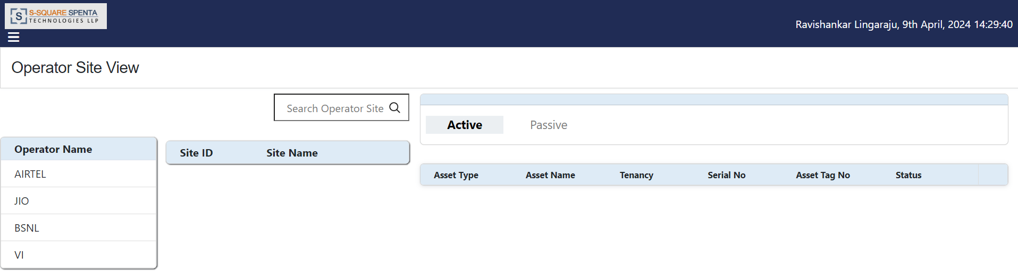

1. The operators are listed in the Operator Name list.
2. On clicking any operator, the Sites assigned to the selected Operator are listed in the Site list.

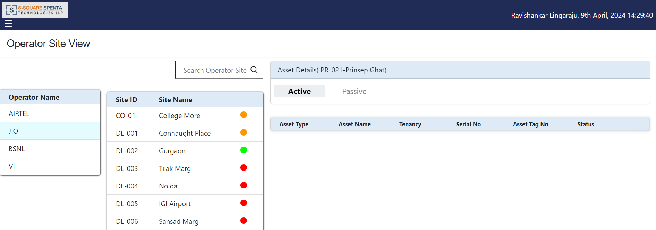

1. On the top of the site list there is a search bar where the user can search site for the selected operator.

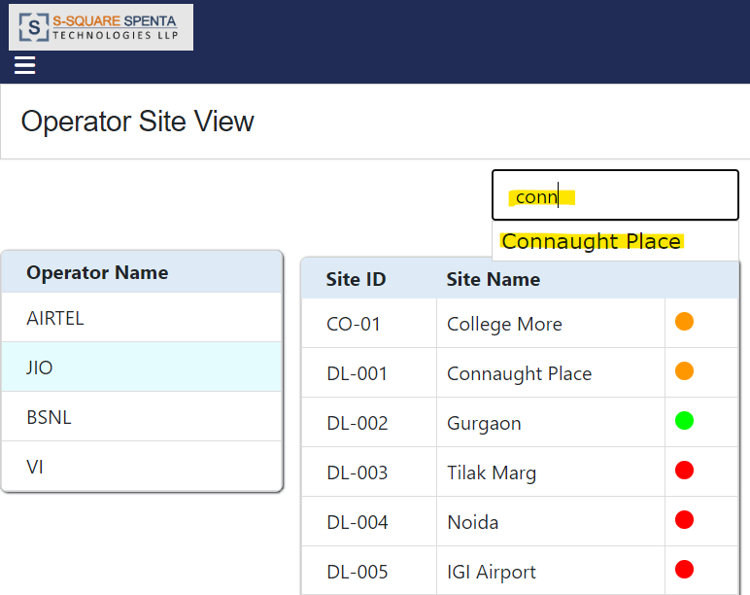

1. On clicking any site from the site list, the Active Assets assigned to the selected Site are listed in the Asset Id list.

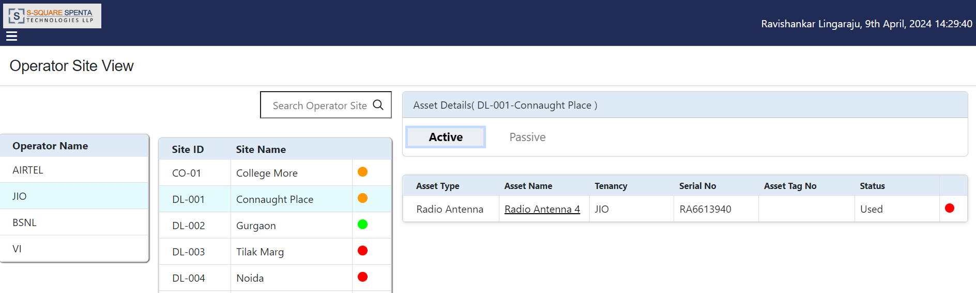

1. On clicking the Passive Tab, the Passive Assets assigned to the selected Site are listed.

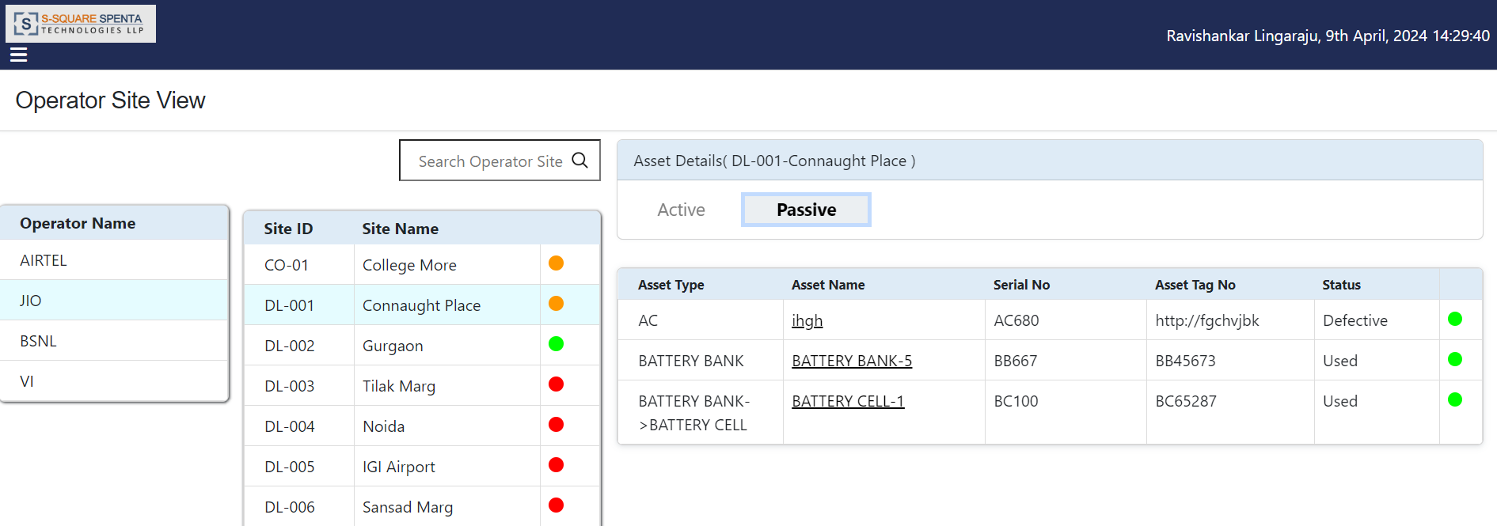

1. Now by clicking on any of the Asset Name will open a pop-up tab with the details of that particular asset. Asset detail displays the tagging history also.

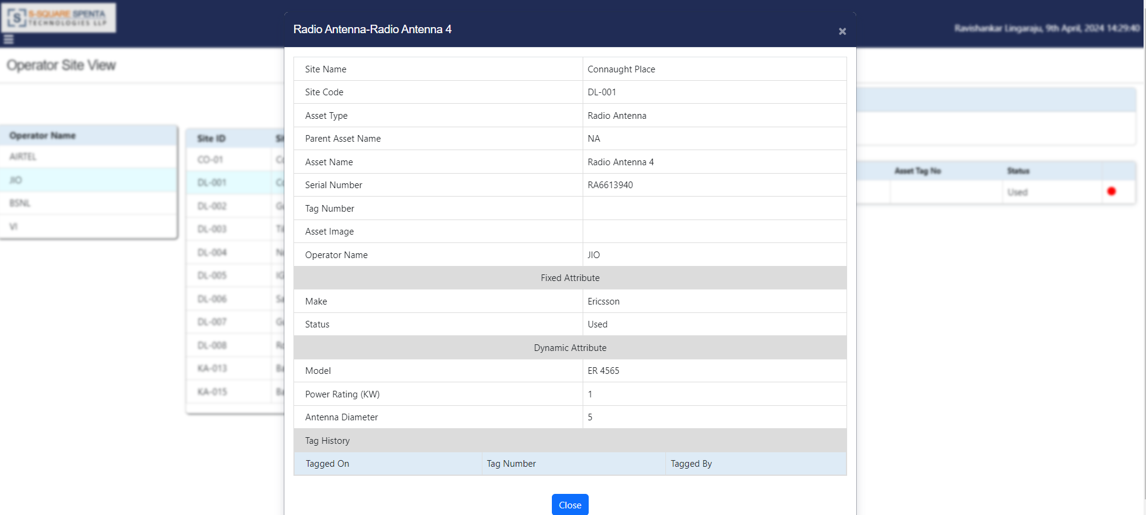

1. Clicking on the Close button to close the asset details pop-up.

# Technician Supervisor Mapping

1. Click on the Technician Supervisor Mapping option from the hamburger menu, the following page is displayed.

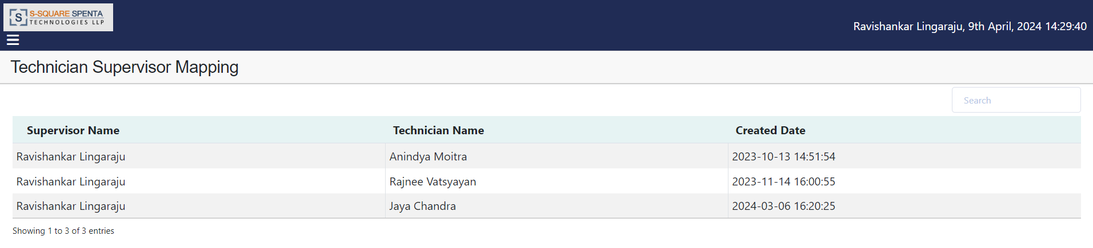

1. Here user can view the technicians under the logged in supervisors.
2. Supervisor can search a user by typing the name of the user at the search box present at the top right of the screen.

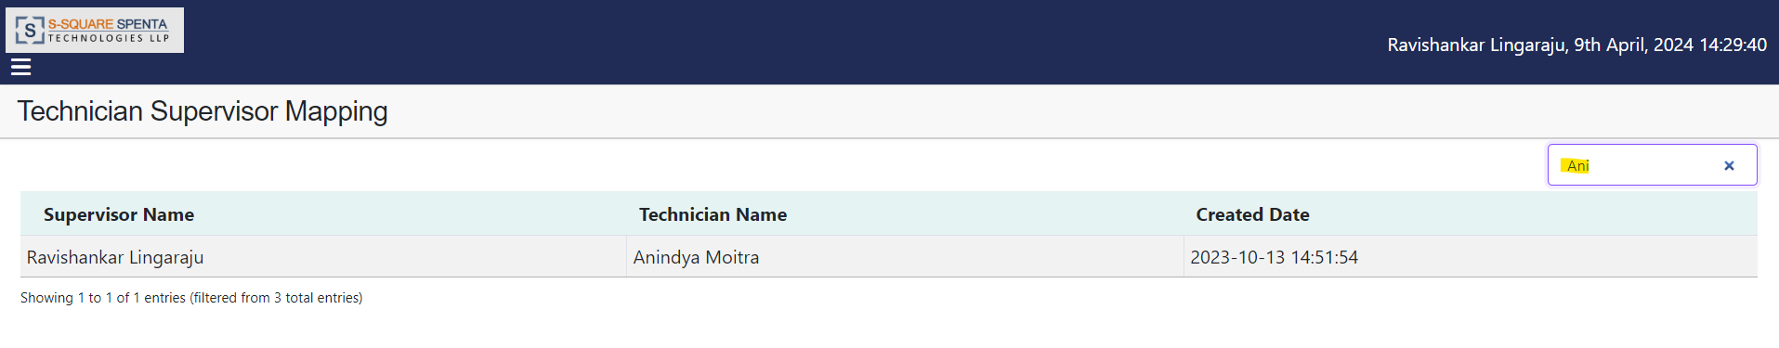

1. Login as Administrator user and go to the Technician Supervisor Mapping screen.
2. To map a technician with a supervisor, select the technician name and supervisor name from dropdown list and click Map option.

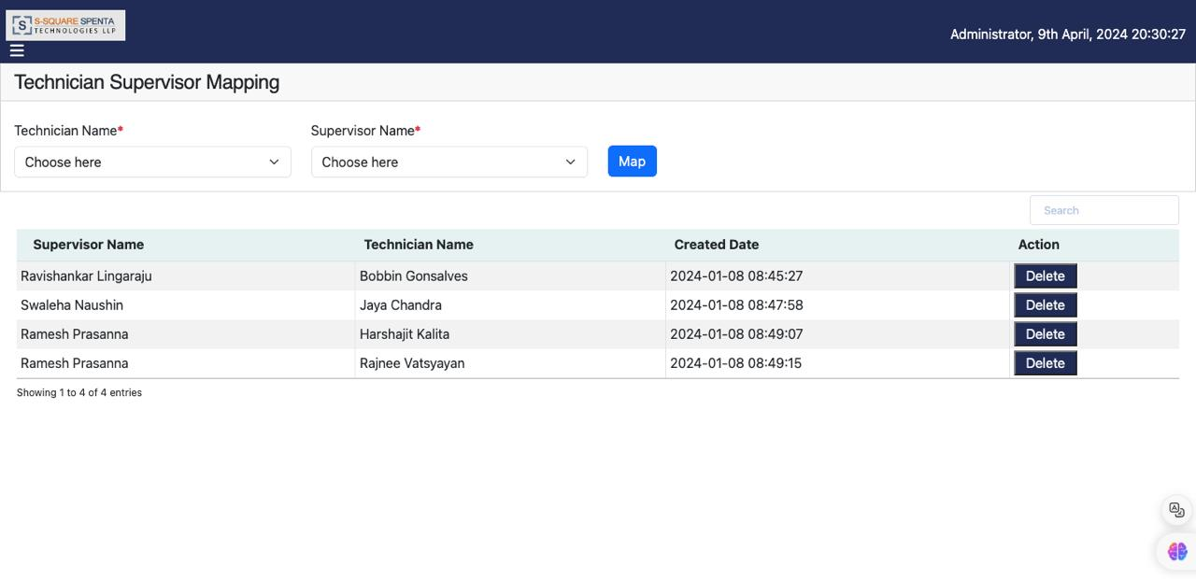

1. To remove mapping of a technician with a supervisor, click Delete option from the supervisor- technician map list.

# Site Asset View

1. Click on the Site Asset View option from the hamburger menu, the following page is displayed.

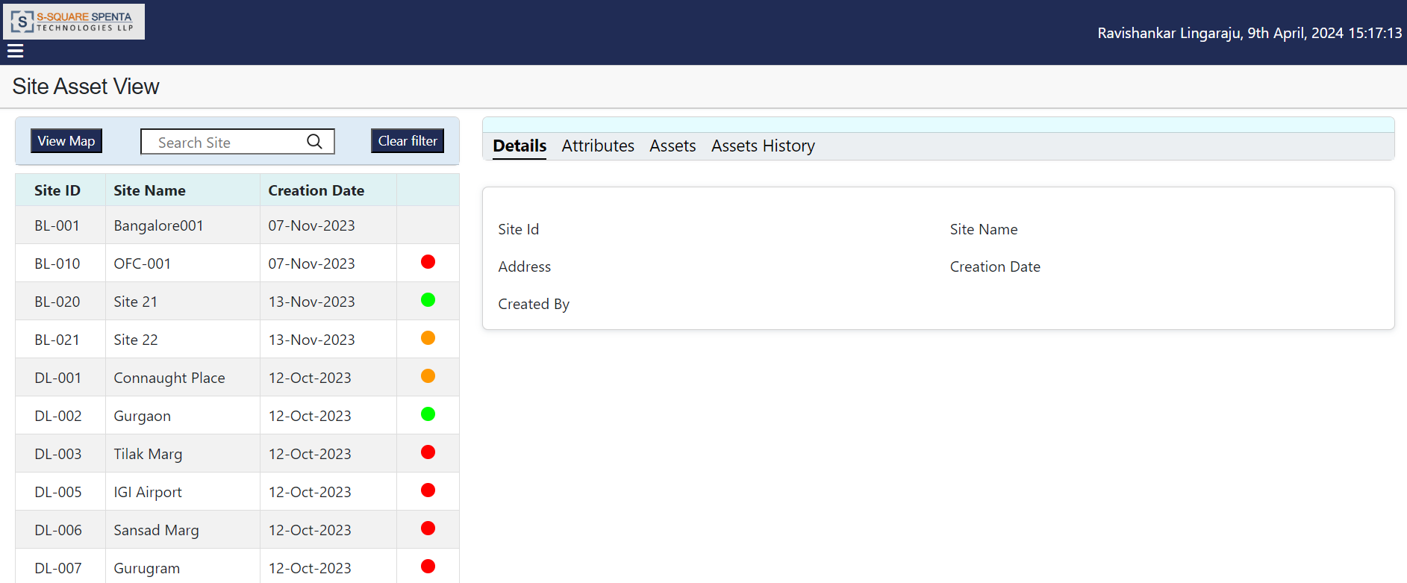

1. On the top of the site list there is a search box where the user can search any site using Site ID or Site Name. User can select a site from the search list to go to that site. Then user can click on the ‘Clear filter’ option beside the search box to clear the set filter to display all the sites.

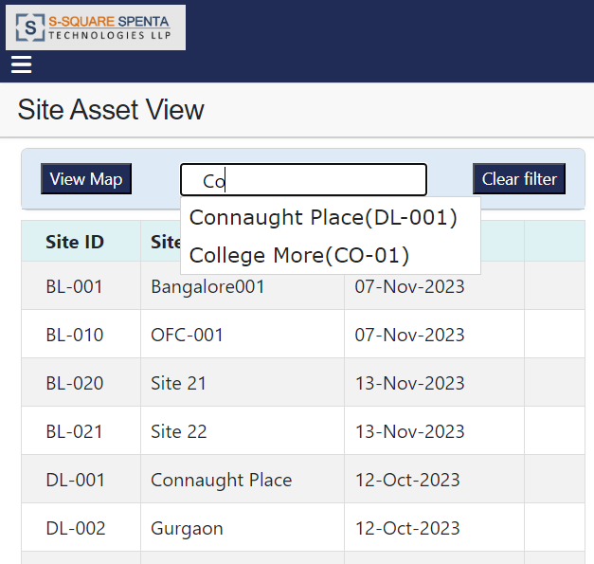

1. Click on View Map option. Click Allow on the popup if any to access to current location. Map will be displayed on the screen where the Sites within a particular radius will be displayed on the map with colour code. Blue circle on the map indicates current location of the user. Green colour implies all assets are tagged in the site, amber colour implies some assets are not tagged in the site and white colour implies all assets are not tagged in the site.

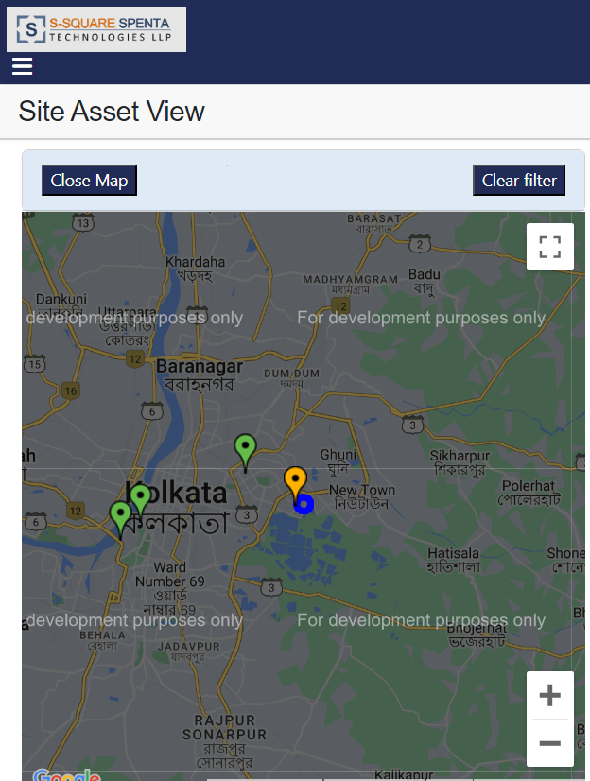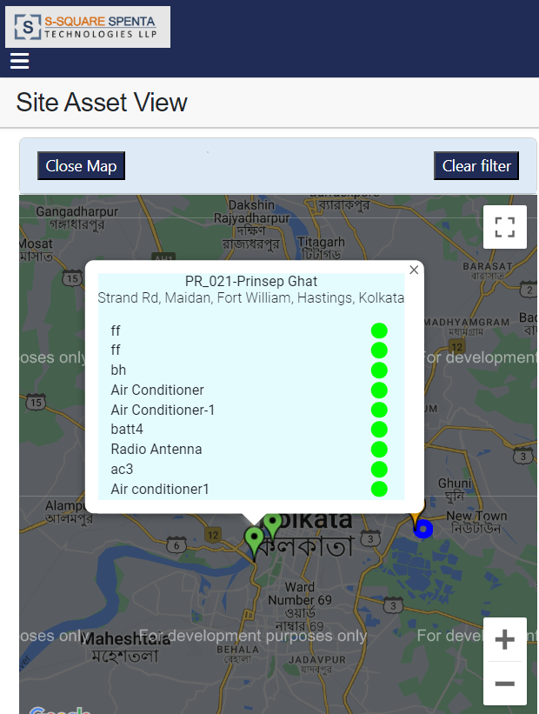

1. Click on any site on the map will pop a screen where all assets of the site with tagging colour status will be displayed.
2. Click on the asset list pop screen. The Passive asset list will be shown at the right side of the screen.

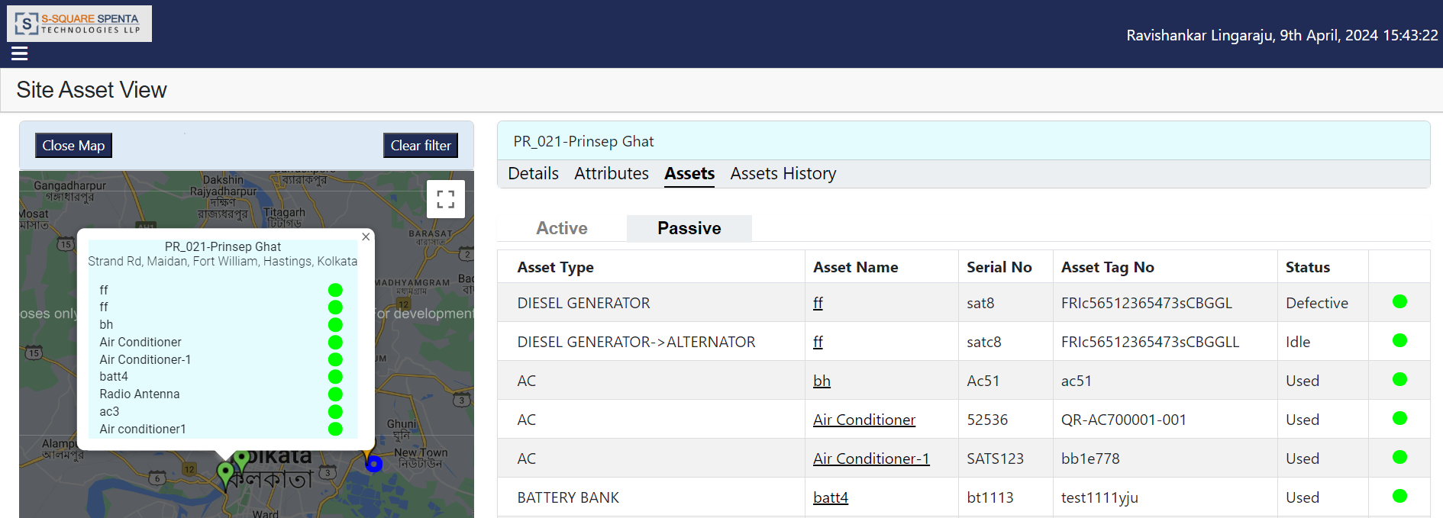

1. User can navigate on other tabs of the screen to view the details of the site and assets of the site.
2. Click on the ‘Close Map’ option to close the map view and go back to the site list view.
3. Click on a site from the site list at the left side of the screen will open the passive assets of the site at the right side of the screen.

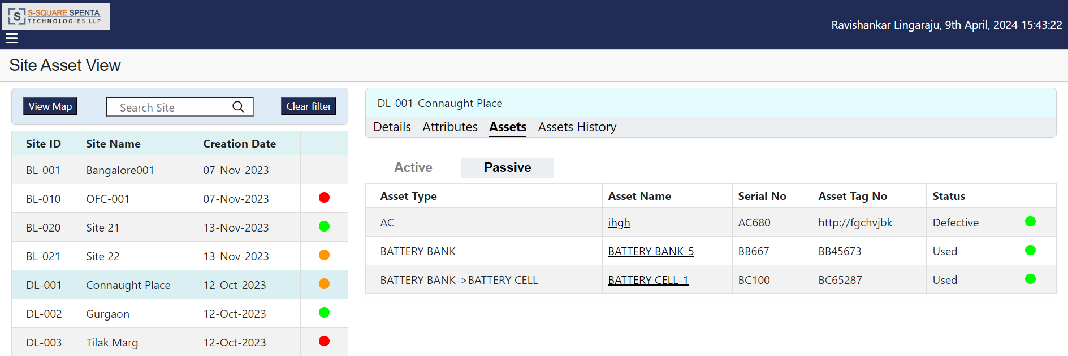

1. Click on the Active tab to view the active assets of the site.

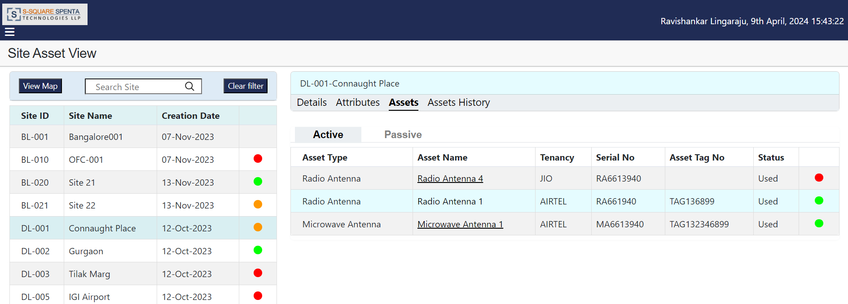

1. Click on asset name to view the details of an asset in a popup screen. Click Close option to close the asset detail popup screen.

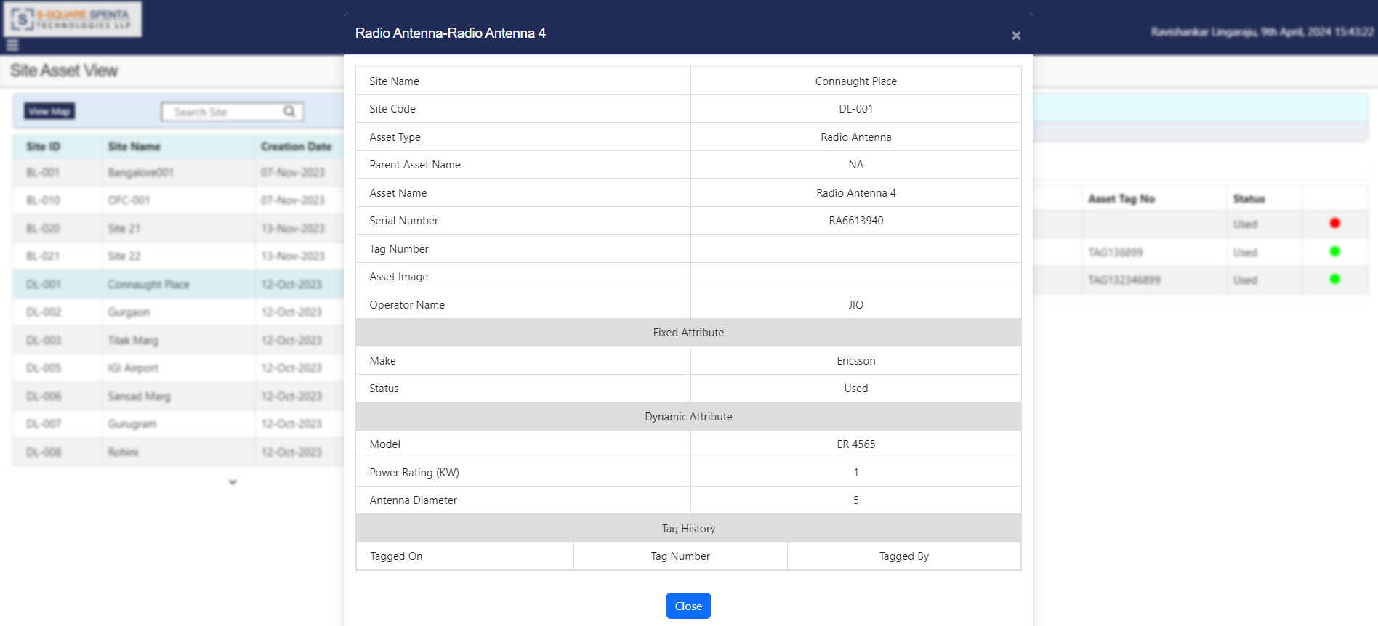

1. Click on the ‘Details’ tab will show the details of the selected site. Asset detail displays the tagging history also.

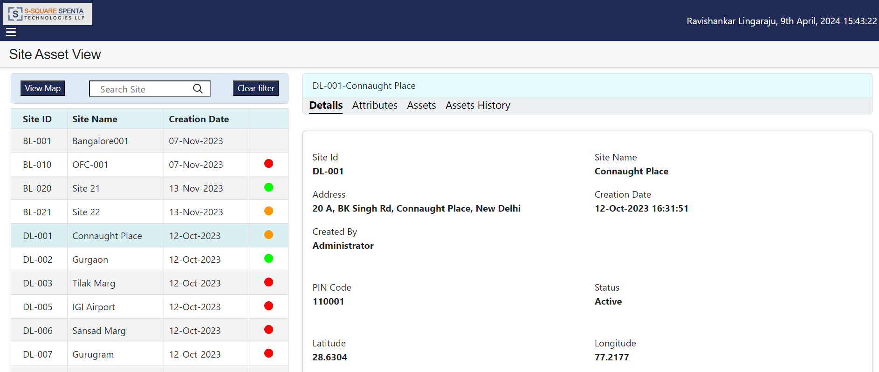

1. Click on the ‘Attributes’ tab will show the attributes of the selected site.

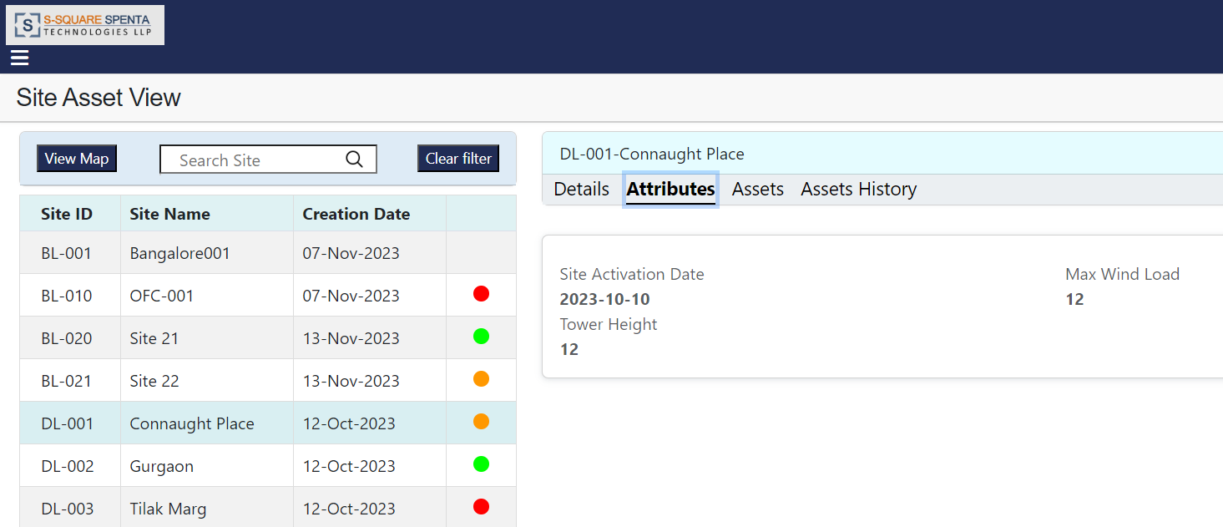

1. Click on the ‘Assets History’ tab will display the history of assets of the selected site. User can click on an asset name to view the details of the asset. Asset detail displays the tagging history also.

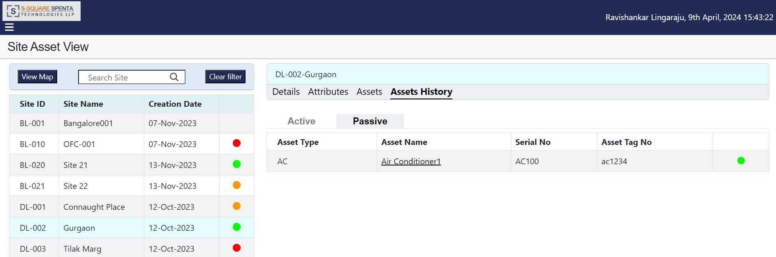

# Asset History

1. Click on the ‘Asset History’ option from the hamburger menu. An empty asset history screen appears where user can search an asset by serial number to view its history.

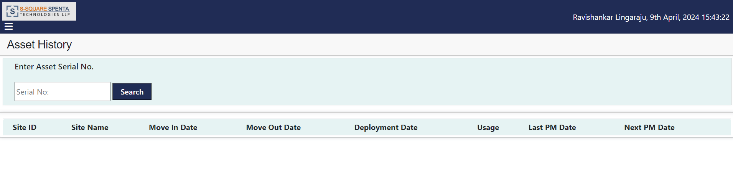

1. Enter a valid Asset Serial No. and click ‘Search’. User will get the movement history of the asset.

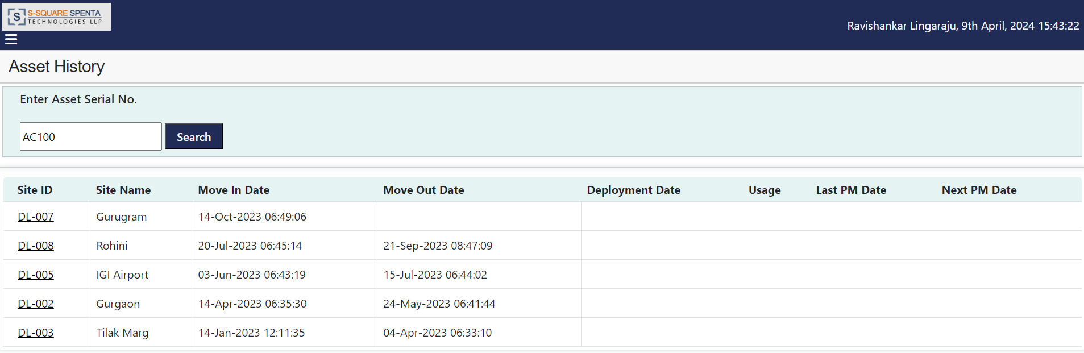

1. The user can view details of the specific asset, inclusive of its complete movement history, with the information displayed in chronological order with the newest movement appearing first.
2. The blank ‘Move Out Date’ indicates the present location of the asset.
3. Click on site id of any row will display the details of the asset.

# Configuration Management

1. Click on the ‘Configuration Management’ option from the hamburger menu. The configuration management screen will appear.

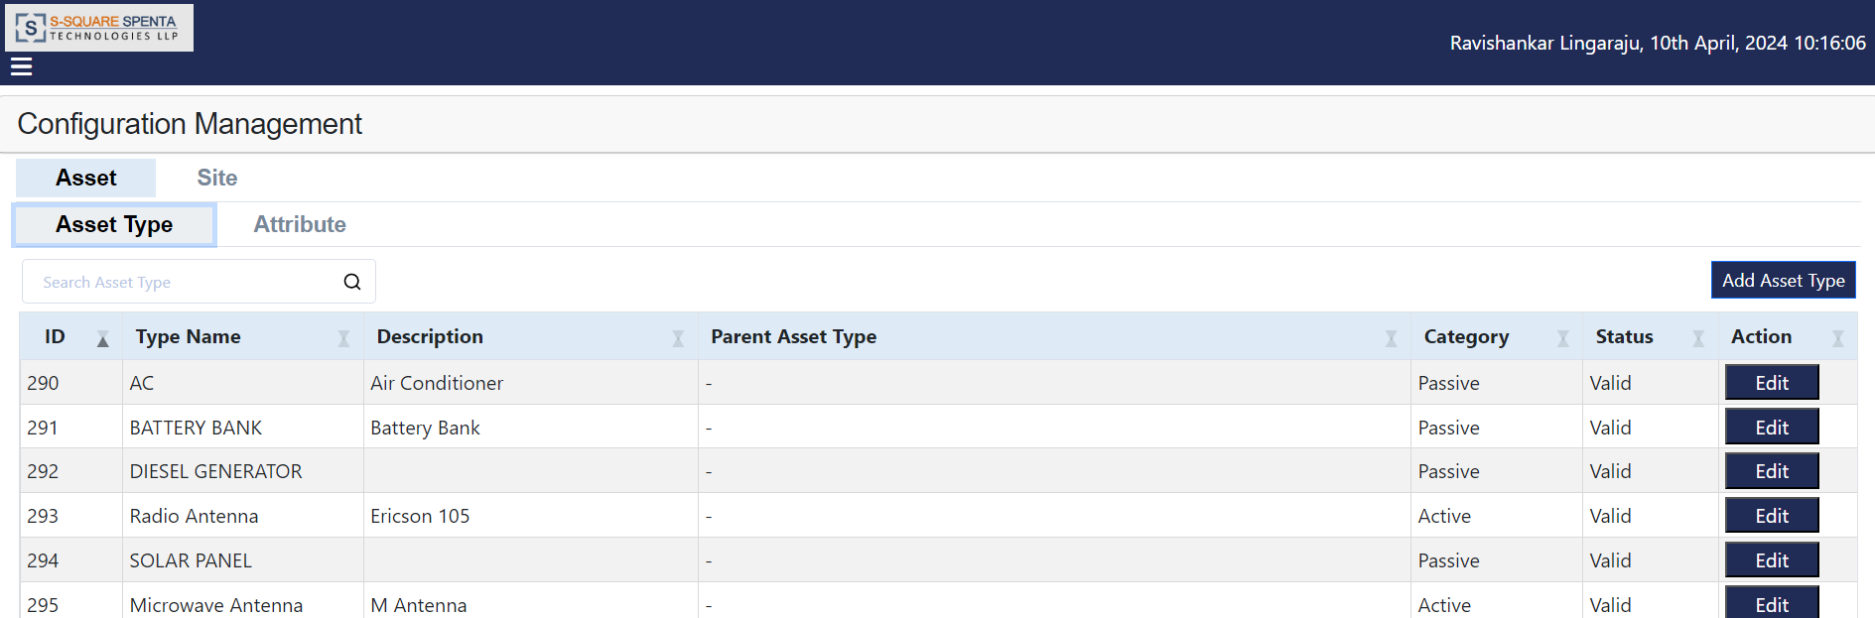

## Asset Type

### Add Asset Type

1. Open ‘Configuration Management’ screen, go to Asset>Asset Type and click ‘Add Asset Type’ option.

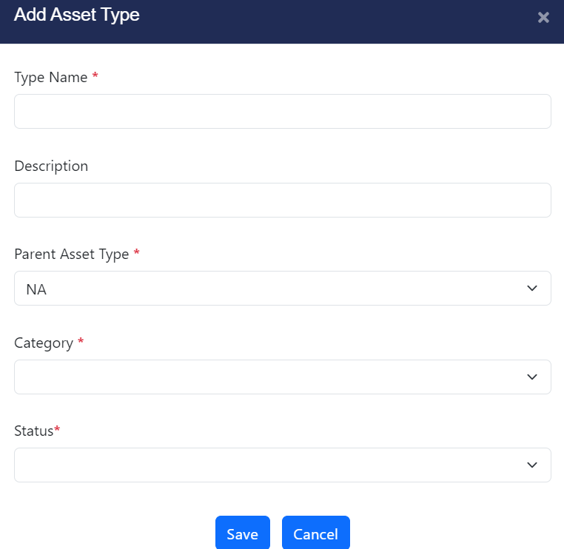

1. Enter all the required data and click on ‘Save’ button. New asset type will be created.
2. User can configure multilevel asset hierarchy (parent-child-grandchild) during asset type definition.

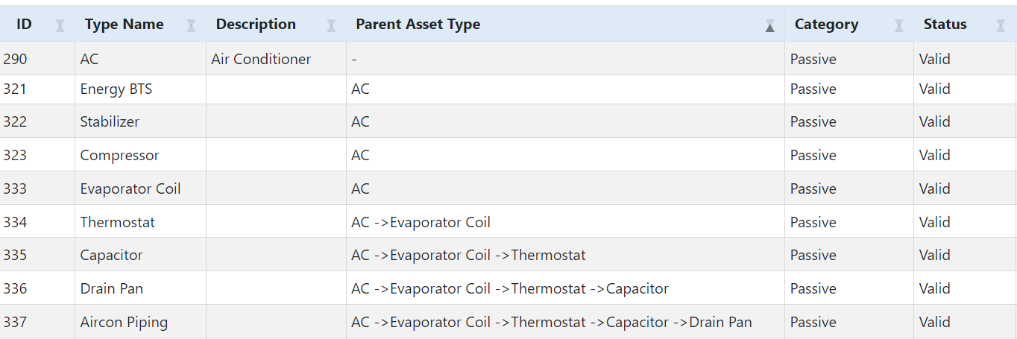

1. Refer the above data example to configure multilevel asset hierarchy.

* ‘AC’ is defined as parent asset type. Parent Asset Type is not applicable here.
* Energy BTS, Stabilizer, Compressor and Evaporator Coil are defined as child asset of AC (Parent Asset Type is ‘AC’ here).
* Thermostat is defined as child of Evaporator Coil (Parent Asset Type is ‘AC ->Evaporator Coil’ here).
* Capacitor is defined as child of Thermostat (Parent Asset Type is ‘AC ->Evaporator Coil ->Thermostat’ here).
* Drain Pan is defined as child of Capacitor (Parent Asset Type is ‘AC ->Evaporator Coil ->Thermostat ->Capacitor’ here).
* Aircon Piping is defined as child of Drain Pan (Parent Asset Type is ‘AC ->Evaporator Coil ->Thermostat ->Capacitor ->Drain Pan’ here).

### Modify Asset Type

1. Open ‘Configuration Management’ screen, go to Asset>Asset Type and click ‘Edit’ option of the asset type that user wants to modify.

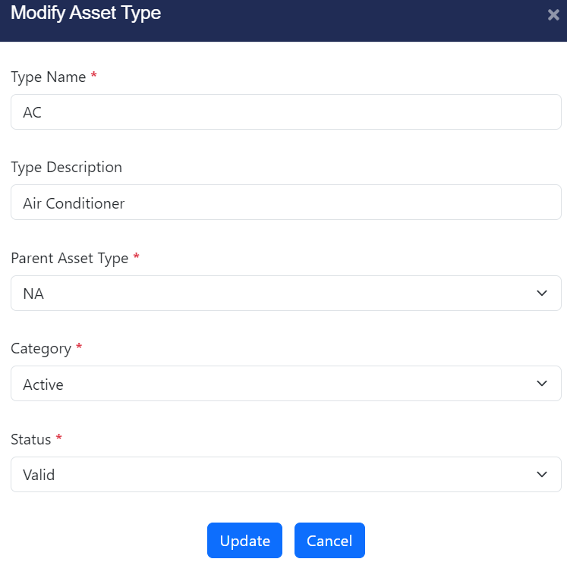

1. Modify the required data and click on ‘Update’ button. Asset type data will be modified.

## Asset Attribute

### Fixed Attribute

#### Add Attribute

1. Open ‘Configuration Management’ screen, go to Asset>Attribute>Fixed and click ‘Add Attribute’ option.

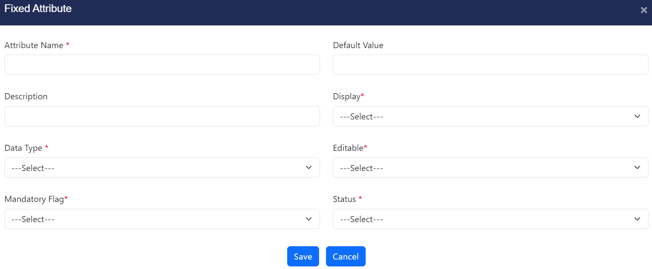

1. Enter all the required data and click on ‘Save’ button. New fixed attribute for asset will be created.

#### Update Attribute

1. Open ‘Configuration Management’ screen, go to Asset>Attribute>Fixed and click ‘Edit’ option of the attribute that user wants to modify.

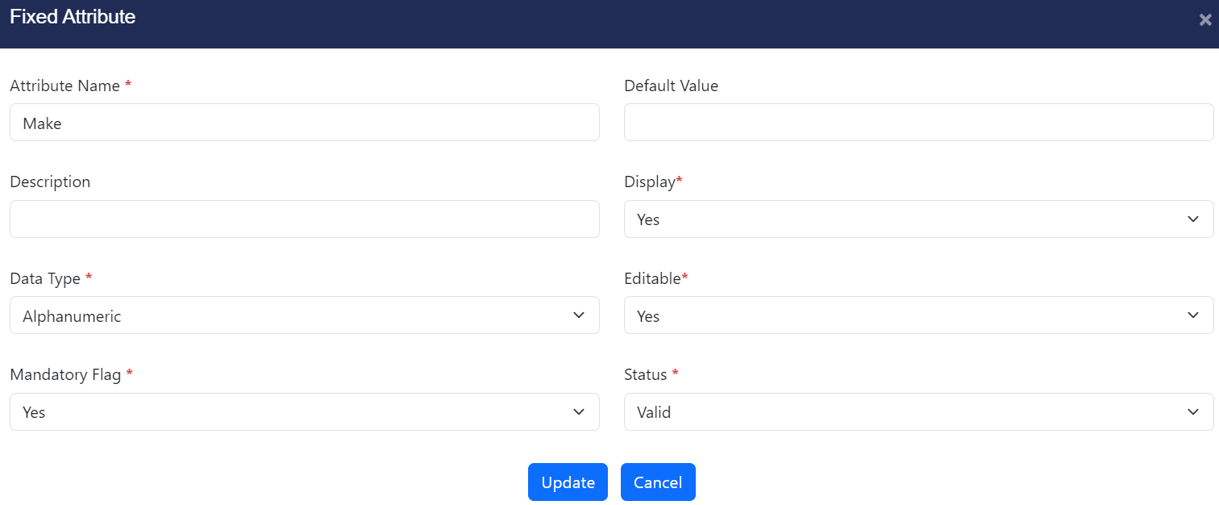

1. Modify the required data and click on ‘Update’ button. Attribute data will be modified.

### Dynamic Attribute

#### Add Attribute

1. Open ‘Configuration Management’ screen, go to Asset>Attribute>Dynamic and click ‘Add Attribute’ option.

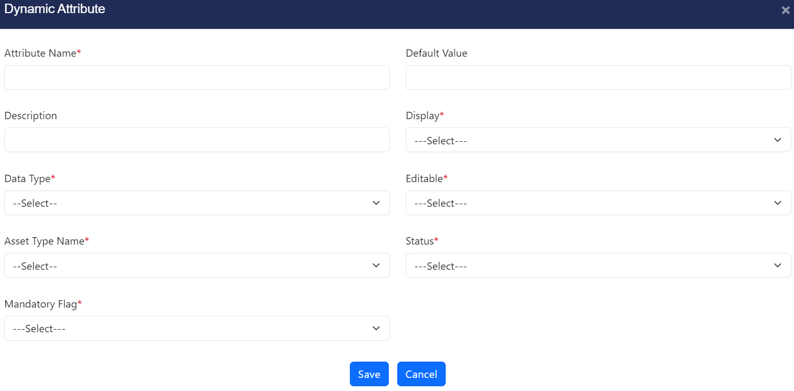

1. Enter all the required data and click on ‘Save’ button. New dynamic attribute for asset will be created.

#### Update Attribute

1. Open ‘Configuration Management’ screen, go to Asset>Attribute>Dynamic and click ‘Edit’ option of the attribute that user wants to modify.

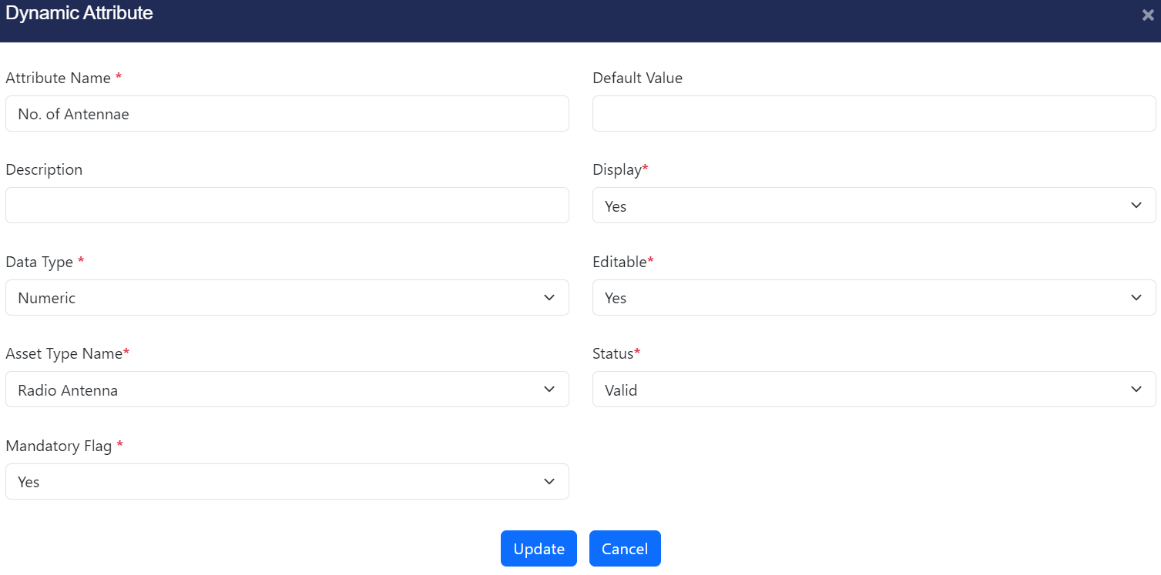

1. Modify the required data and click on ‘Update’ button. Attribute data will be modified.

## Site Type

### Add Site Type

1. Open ‘Configuration Management’ screen, go to Site>Site Type and click ‘Add Site Type’ option.

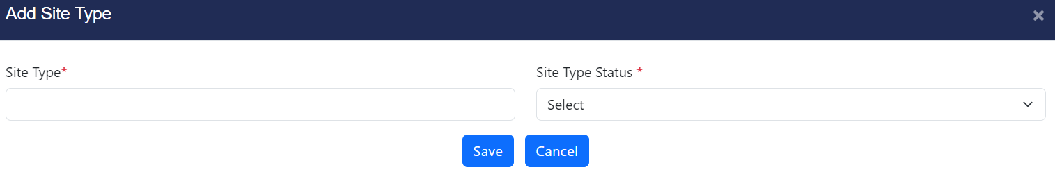

1. Enter all the required data and click on ‘Save’ button. New site type will be created.

### Update Site Type

1. Open ‘Configuration Management’ screen, go to Site>Site Type and click ‘Edit’ option of the site type that user wants to modify.

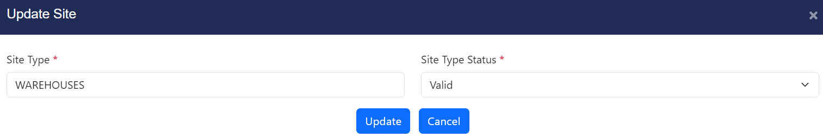

1. Modify the required data and click on ‘Update’ button. Site type data will be modified.

## Site Attribute

### Fixed Attribute

#### Add Attribute

1. Open ‘Configuration Management’ screen, go to Site>Attribute>Fixed and click ‘Add Attribute’ option.

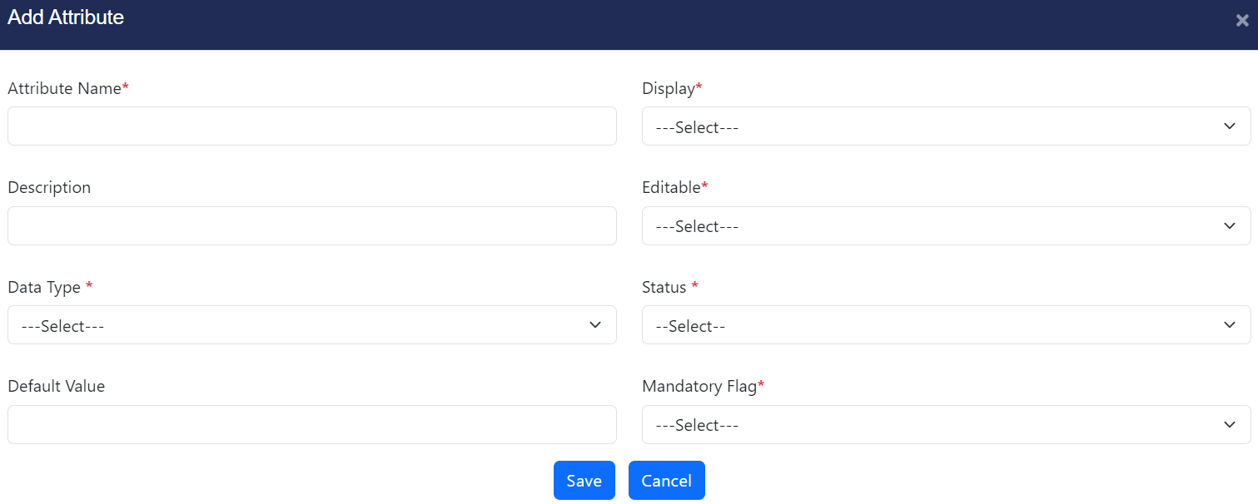

1. Enter all the required data and click on ‘Save’ button. New site attribute will be created.

#### Update Attribute

1. Open ‘Configuration Management’ screen, go to Site>Attribute>Fixed and click ‘Edit’ option of the attribute that user wants to modify.

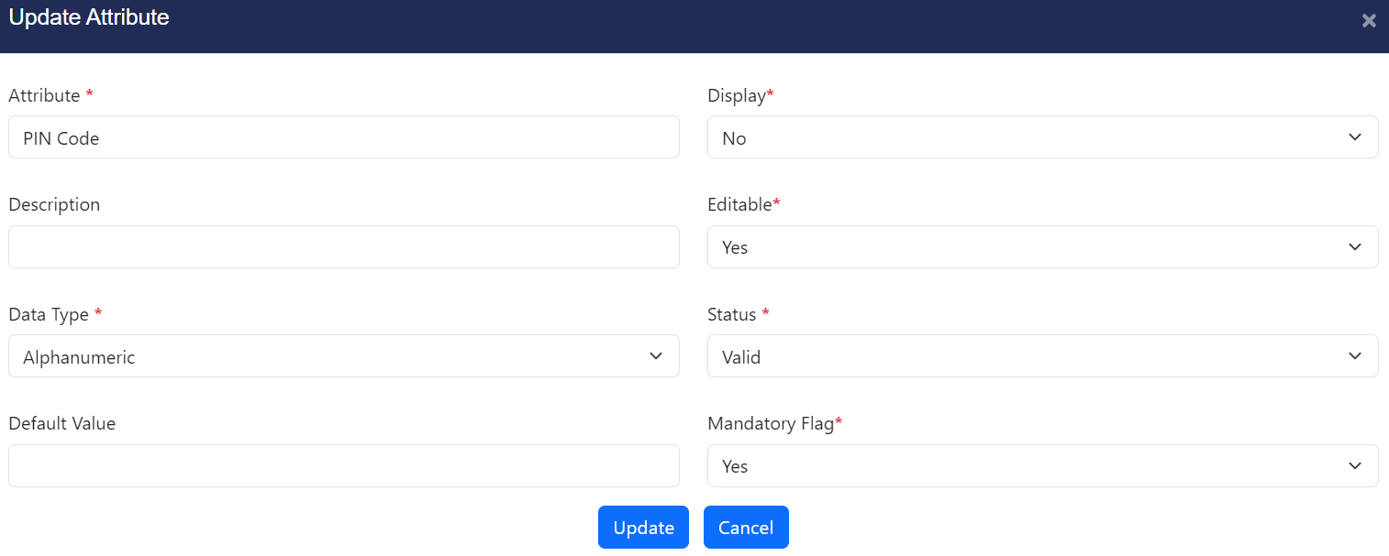

1. Modify the required data and click on ‘Update’ button. Site attribute data will be modified.

### Dynamic Attribute

#### Add Attribute

1. Open ‘Configuration Management’ screen, go to Site>Attribute>Dynamic and click ‘Add Attribute’’ option.

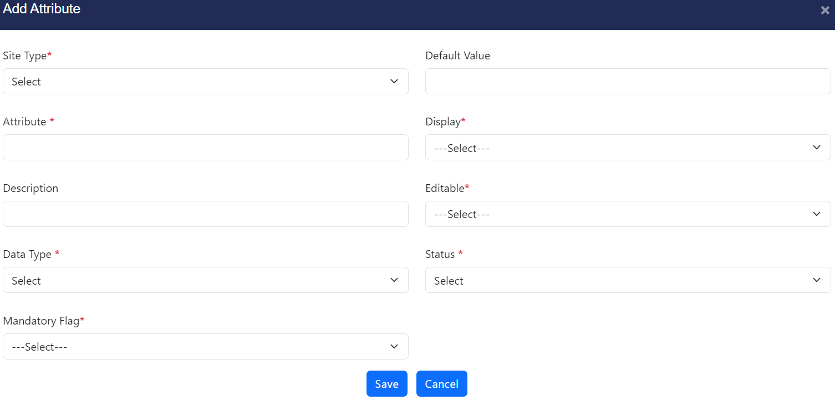

1. Enter all the required data and click on ‘Save’ button. New site attribute will be created.

#### Update Attribute

1. Open ‘Configuration Management’ screen, go to Site>Attribute>Dynamic and click ‘Edit’ option of the attribute that user wants to modify.

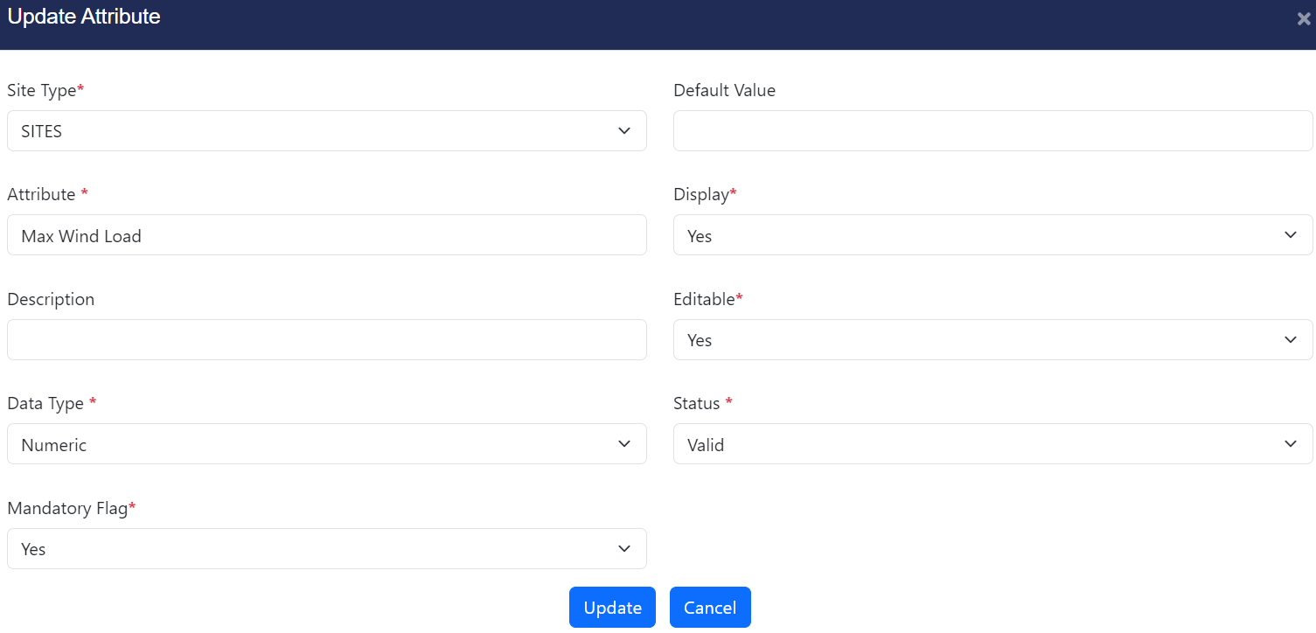

1. Modify the required data and click on ‘Update’ button. Site attribute data will be modified.

## Site

### Add Site

1. Open ‘Configuration Management’ screen, go to Site>Site and click ‘Add Site’ option.

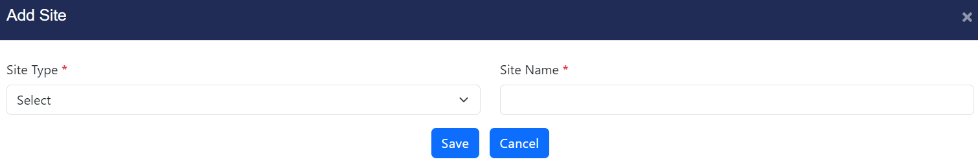

1. Enter all the required data and click on ‘Save’ button. New site will be created.

### Update Site

1. Open ‘Configuration Management’ screen, go to Site>Site and click ‘Edit’ option of the site that user wants to modify.

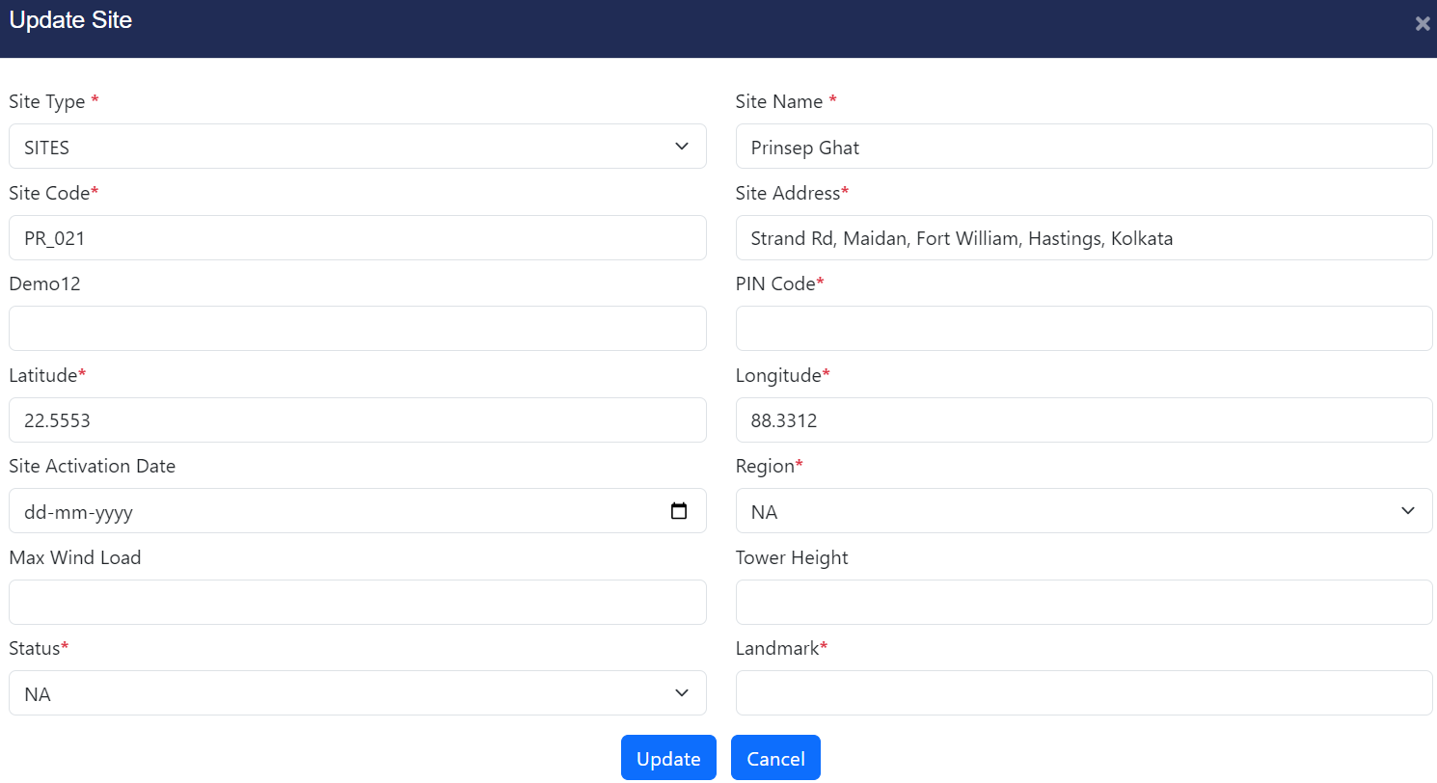

1. Modify the required data and click on ‘Update’ button. Site data will be modified.

# Batch Process

## Technician to Site Mapping

1. Click on the ‘Batch Process’ option from the hamburger menu, user will be presented with the Technician to Site Mapping batch upload screen.

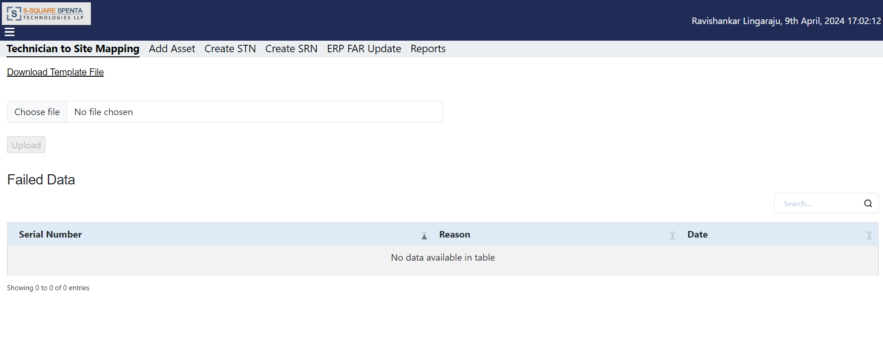

1. Click on the ‘Download Template File’ link and save the file (User_site_tagging.xlsx) at local drive.
2. Open the file, provide the required data and save the excel file. Refer the cell comment while filling up the data in the template file.
3. Rename the file with a suitable name (e.g. UserSiteMap_01Jan204_01.xlsx).
4. To upload the file, click the ‘Choose File’ option to browse and select the file from local drive. The ‘Upload’ button gets enabled.

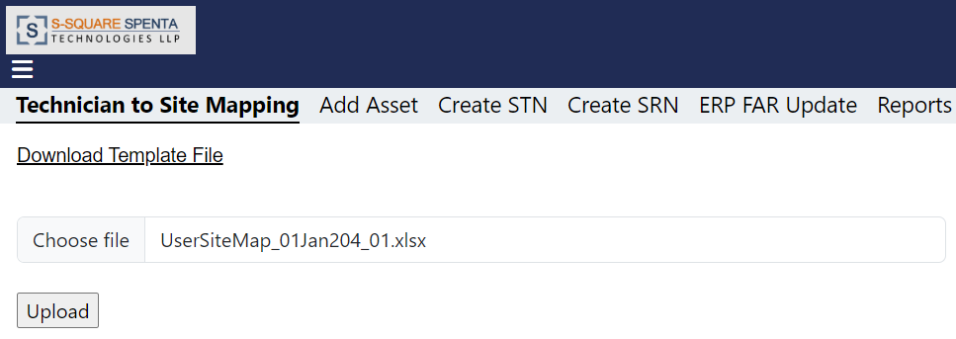

1. To initiate the batch process, the click on the 'Upload' button.
2. This action will process and upload the file data as part of the batch process.
3. For the record with Action Flag ‘Allocate’, the site will be assigned to user and will be visible for the respective user at both on web portal (Technician to Site Tagging Status) and mobile app (My Site).
4. For the record with Action Flag ‘Deallocate’, the site will be de-assigned from user and will not be visible for the respective user at both on web portal.

## Add Asset

1. Click on the ‘Batch Process’ option from the hamburger menu, user will be presented with the Technician to Site Mapping batch upload screen. Then click on the ‘Add Asset’ tab.

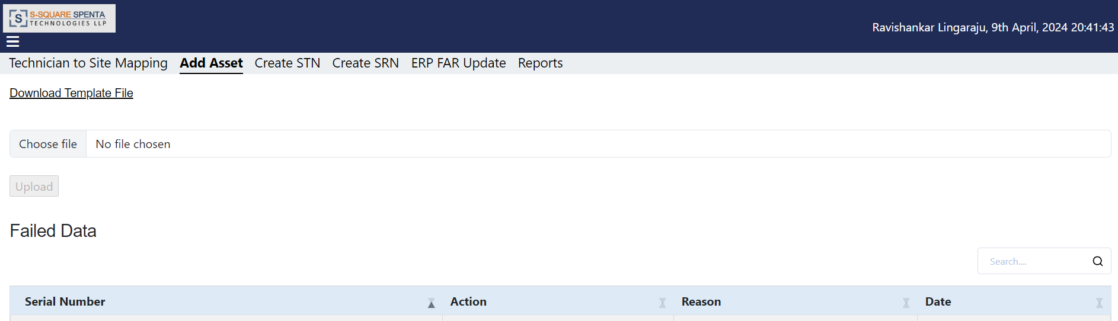

1. Click on the ‘Download Template File’ link and save the file (ADD_ASSETS.xlsx) at local drive.
2. Open the file, provide the required data and save the excel file. Refer the cell comment while filling up the data in the template file. The blue fields are mandatory. User can add more Attribute and Attribute Value data in the file.
3. Rename the file with a suitable name (e.g. AddAsset_01Jan204_01.xlsx).
4. To upload the file, click the ‘Choose File’ option to browse and select the file from local drive. The ‘Upload’ button gets enabled.

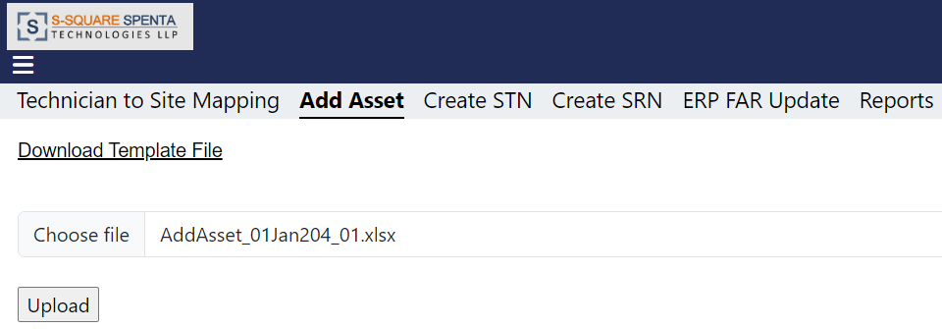

1. To initiate the batch process, the click on the 'Upload' button.
2. This action will process and upload the file data as part of the batch process.
3. Asset will be added to the SATS asset database.

## Create STN

1. Click on the ‘Batch Process’ option from the hamburger menu, user will be presented with the Technician to Site Mapping batch upload screen. Then click on the ‘Create STN’ tab.

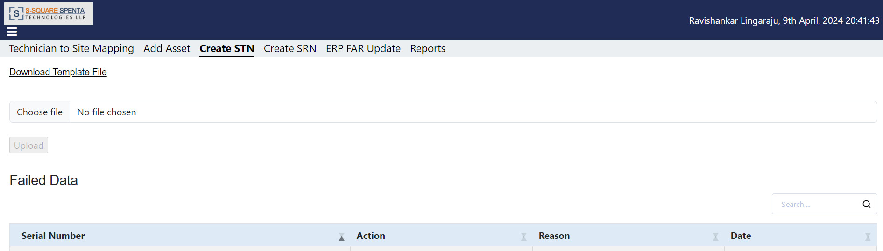

1. Click on the ‘Download Template File’ link and save the file (CREATE_STN.xlsx) at local drive.
2. Open the file, provide the required data and save the excel file. Refer the cell comment while filling up the data in the template file. The blue fields are mandatory. User can add more Attribute and Attribute Value data in the file.
3. Rename the file with a suitable name (e.g. CreateSTN_01Jan204_01.xlsx).
4. To upload the file, click the ‘Choose File’ option to browse and select the file from local drive. The ‘Upload’ button gets enabled.

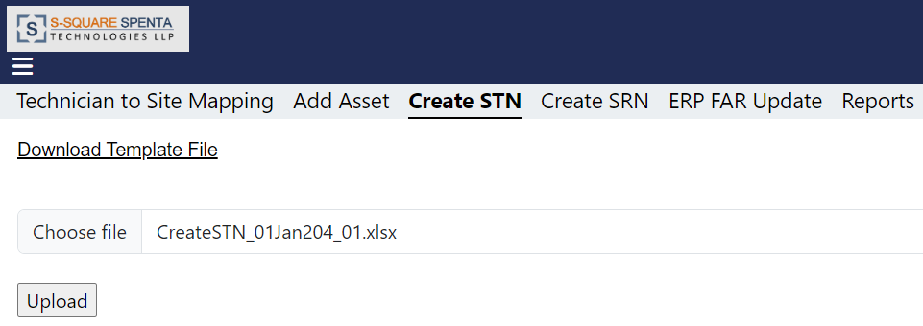

1. To initiate the batch process, the click on the 'Upload' button.
2. This action will process and upload the file data as part of the batch process.
3. The STN Task will be visible at the site Task List of the respective site technician Mobile App.

## Create SRN

1. Click on the ‘Batch Process’ option from the hamburger menu, user will be presented with the Technician to Site Mapping batch upload screen. Then click on the ‘Create SRN’ tab.

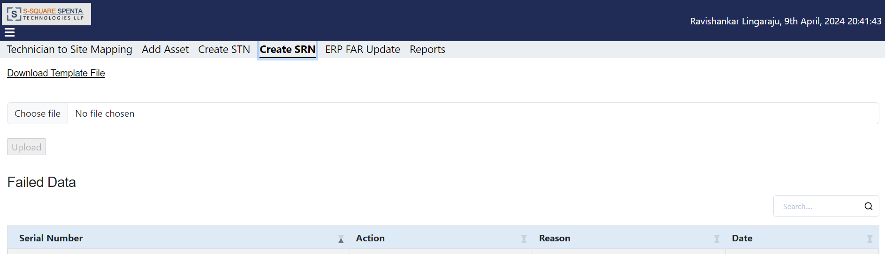

1. Click on the ‘Download Template File’ link and save the file (CREATE_SRN.xlsx) at local drive.
2. Open the file, provide the required data and save the excel file. Refer the cell comment while filling up the data in the template file. The blue fields are mandatory. User can add more Attribute and Attribute Value data in the file.
3. Rename the file with a suitable name (e.g. CreateSRN_01Jan204_01.xlsx).
4. To upload the file, click the ‘Choose File’ option to browse and select the file from local drive. The ‘Upload’ button gets enabled.

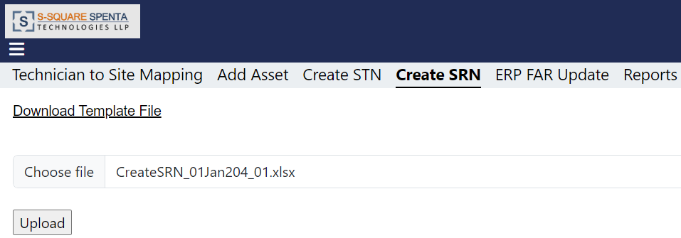

1. To initiate the batch process, the click on the 'Upload' button.
2. This action will process and upload the file data as part of the batch process.
3. The SRN Task will be visible at the site Task List of the respective site technician Mobile App.

## ERP FAR Update

1. Click on the ‘Batch Process’ option from the hamburger menu, user will be presented with the Technician to Site Mapping batch upload screen. Then click on the ‘ERP FAR Update’ tab.

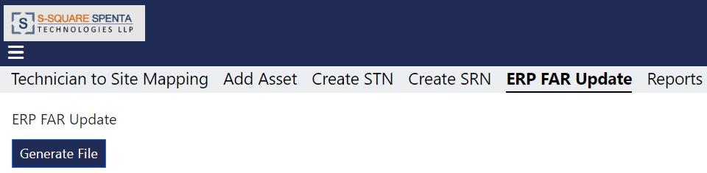

1. Click on the ‘Generate File’ button and save the asset report file (e.g. 09042024_223341.xlsx) at local drive.

## Reports

### Fully Tagged Sites

1. Click on the ‘Batch Process’ option from the hamburger menu, user will be presented with the Technician to Site Mapping batch upload screen. Then click on the ‘Reports’ tab.

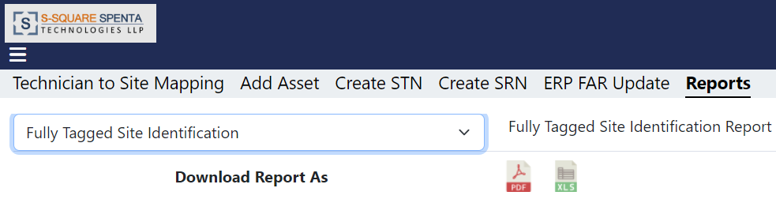

1. Select report name from the dropdown list. Only the reports which are developed and configured will be available in the dropdown list.
2. Click on the PDF icon to download the report. The report will be generated and displayed in PDF format and opened in a new tab.

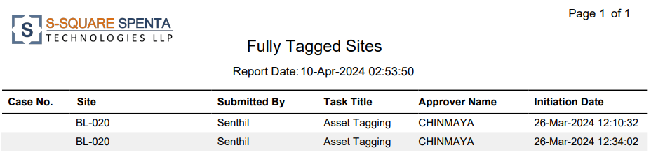

### Not Found Asset

1. Click on the ‘Batch Process’ option from the hamburger menu, user will be presented with the Technician to Site Mapping batch upload screen. Then click on the ‘Reports’ tab.

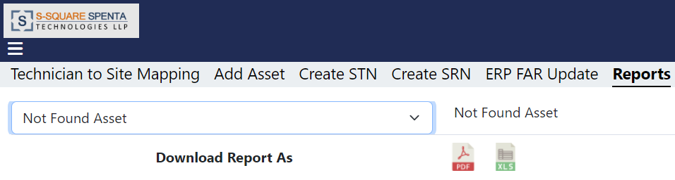

1. Select report name from the dropdown list. Only the reports which are developed and configured will be available in the dropdown list.
2. Click on the PDF icon to download the report. The report will be generated and displayed in PDF format and opened in a new tab.

### Asset Audit

1. Click on the ‘Batch Process’ option from the hamburger menu, user will be presented with the Technician to Site Mapping batch upload screen. Then click on the ‘Reports’ tab.

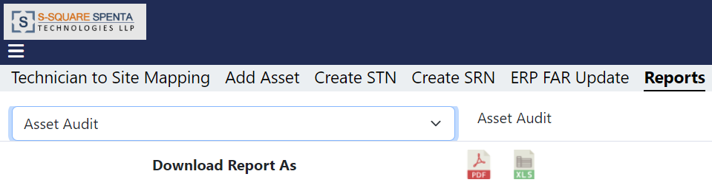

1. Select report name from the dropdown list. Only the reports which are developed and configured will be available in the dropdown list.
2. Click on the PDF icon to download the report. The report will be generated and displayed in PDF format and opened in a new tab.

### Inventory FAR Mismatch

1. Click on the ‘Batch Process’ option from the hamburger menu, user will be presented with the Technician to Site Mapping batch upload screen. Then click on the ‘Reports’ tab.

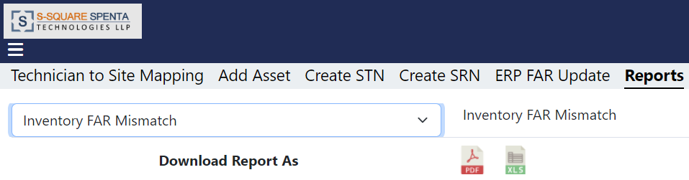

1. Select report name from the dropdown list. Only the reports which are developed and configured will be available in the dropdown list.
2. Click on the PDF icon to download the report. The report will be generated and displayed in PDF format and opened in a new tab.

# Audit Trail

1. Click on the ‘Audit Trail’ option from the hamburger menu, the audit trail screen will be displayed.

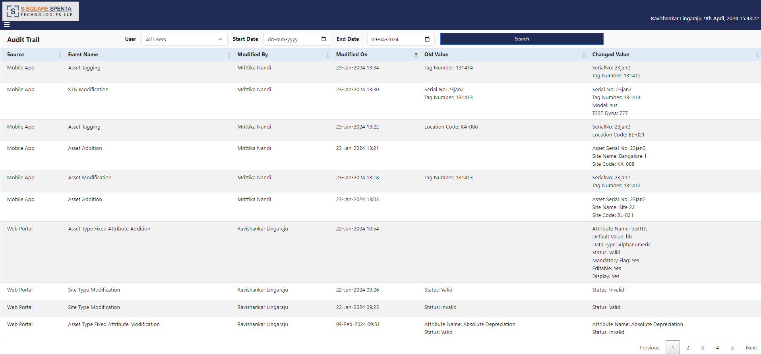

1. Select a user from dropdown list, select start date, end date from calendar and click on ‘Search’ option.

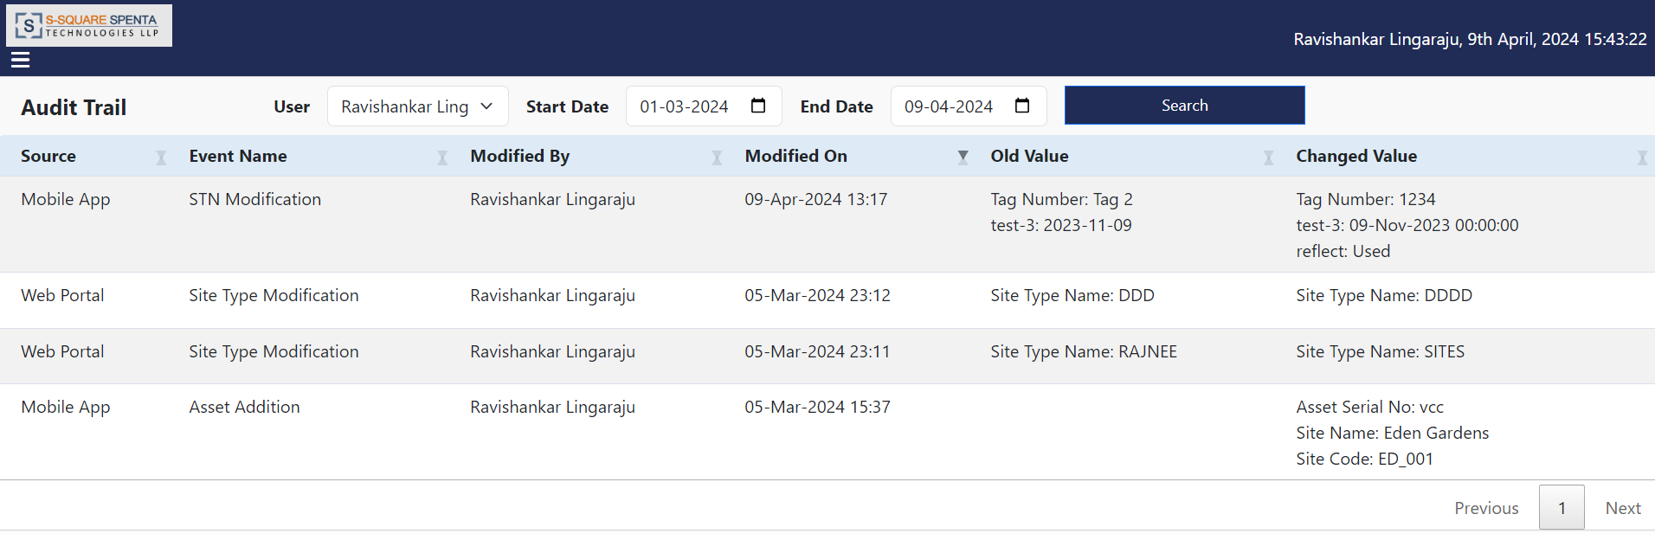

1. The audit trail records for the selected user and given date range will be displayed.

# Report

1. Click on the ‘Report’ option from the hamburger menu, a screen will appear to extract report.

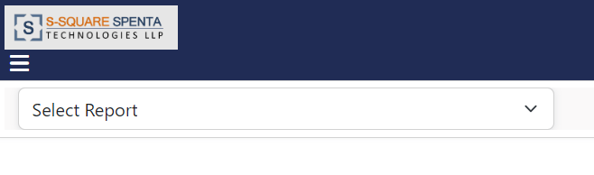

1. Select a report name from the dropdown list. Only the reports which are developed and configured will be available in the dropdown list.

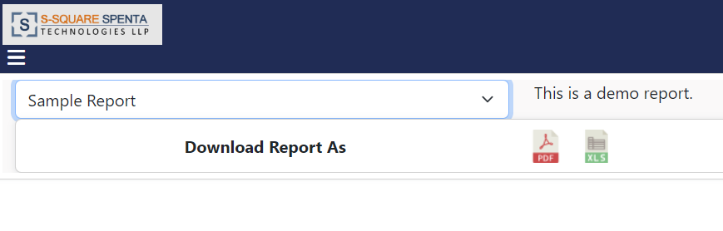

1. Click on the PDF icon to download the report. The report will be generated and displayed in PDF format and opened in a new tab.

# Log Out

1. Click on the ‘Log Out’ option from the hamburger menu, user will be logged out from the portal and redirected to the login page.

